Table of Contents

Movement 5

Vertical Movement / Flappy Bird 5

2D Movement / Eating Snake 6

Horizon, vertical and slope movement, levels set as Sprite 7

Horizon and vertical, levels set as Backdrop 8

Sprite shows at desired level 9

Final Movement Project 10

Projectile Motion (Parabolic Motion) / Fruit Ninja 12

Fight coronavirus \ Go to random without inside sprite 13

T-Rex (Moving Ground / Render Number) 14

Parking Cars 15

Bouncing movement 16

Brick block/ Bouncing/ make clone 17

Swimming Fish 19

Pac Man Game 20

Pac Man I 20

Pac Man II 22

Bomber man 24

Scrolling Platform 25

Scrolling Player 26

Cube Dash Game 27

Scrolling Platform Example 1 30

Scrolling Maze Game 34

3D Effect 37

3D Moving effect 37

3D Cube Moving 38

Clone sprite operation 39

Shooting Zombie / clone sprite 39

Using List to store Clone direction, X, Y 40

Space Fight 41

String operate 43

Render Text with your own font 44

Pen tool 45

Rainbow painting / Random Bubble / Mouse Tracing Bubble 45

Special Effect 47

Shake screen 47

Shining and disappear 47

Rotating shrinking disappear 48

Rising platform 48

Rainbow drawing 49

Move along the road 50

Snow effect 51

Falling leaves 51

Spinning Wheel 52

Tips 53

Draw a square 53

Bouncing 53

Forever -> If mouse down -> pen down Else -> pen up, Does not working 54

Explosion effect 54

How to use backpack 54

Round to two decimal 54

Color trick game 55

Basic concept 56

Broadcast 56

# **Movement**

## **Vertical Movement / Flappy Bird**

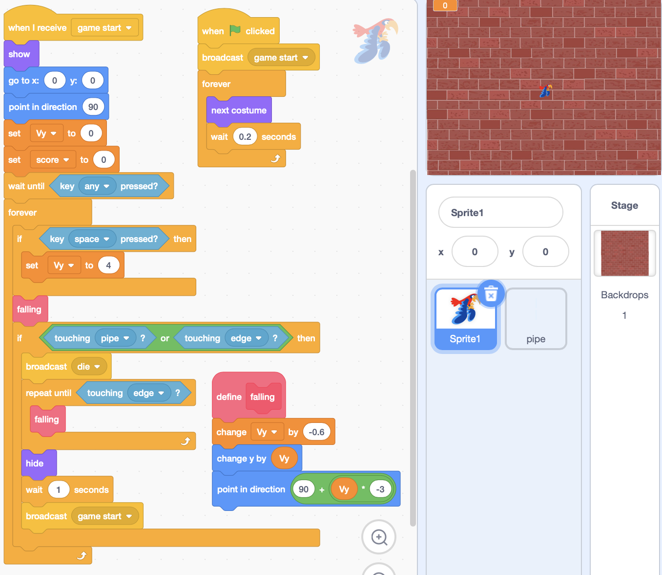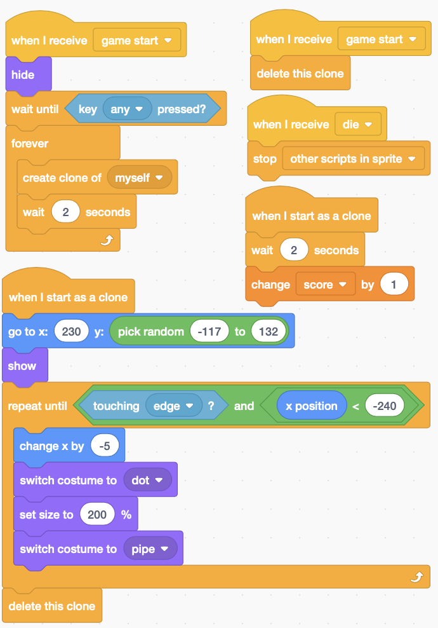

## **2D Movement / Eating Snake**

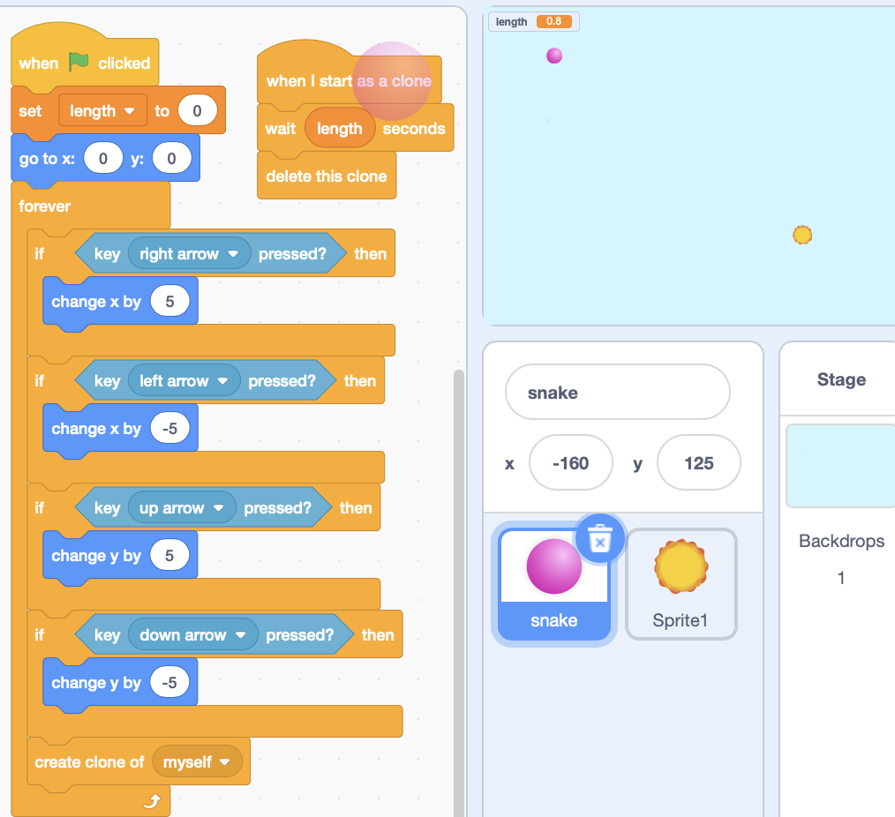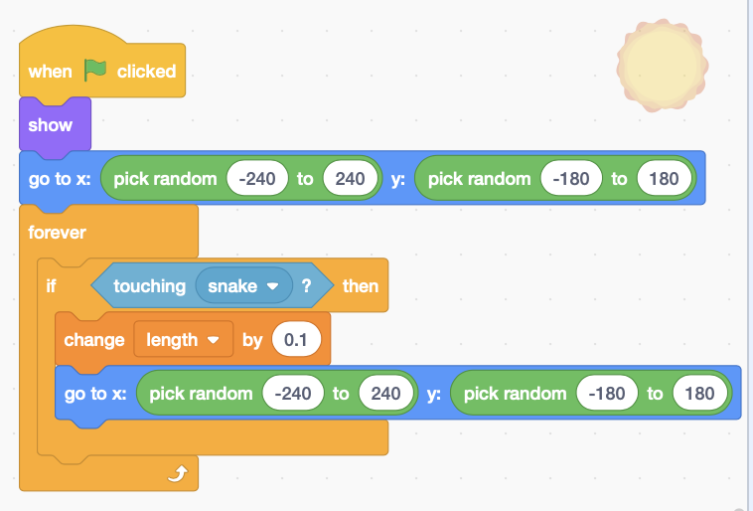

## **Horizon, vertical and slope movement, levels set as Sprite**

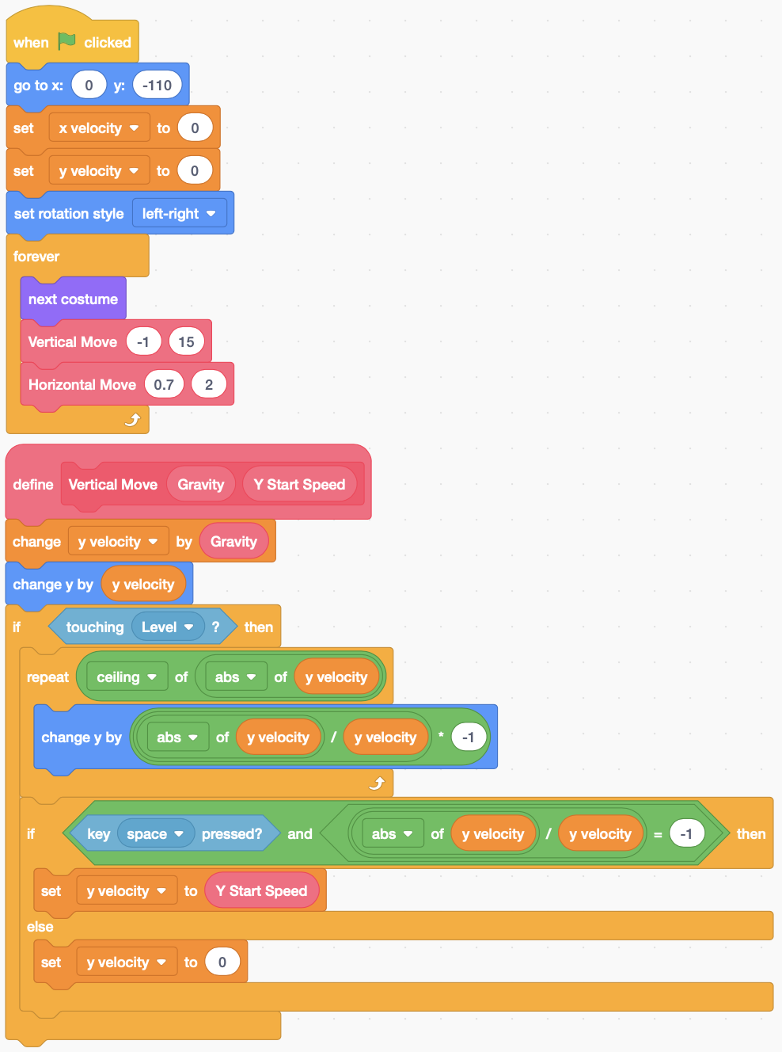 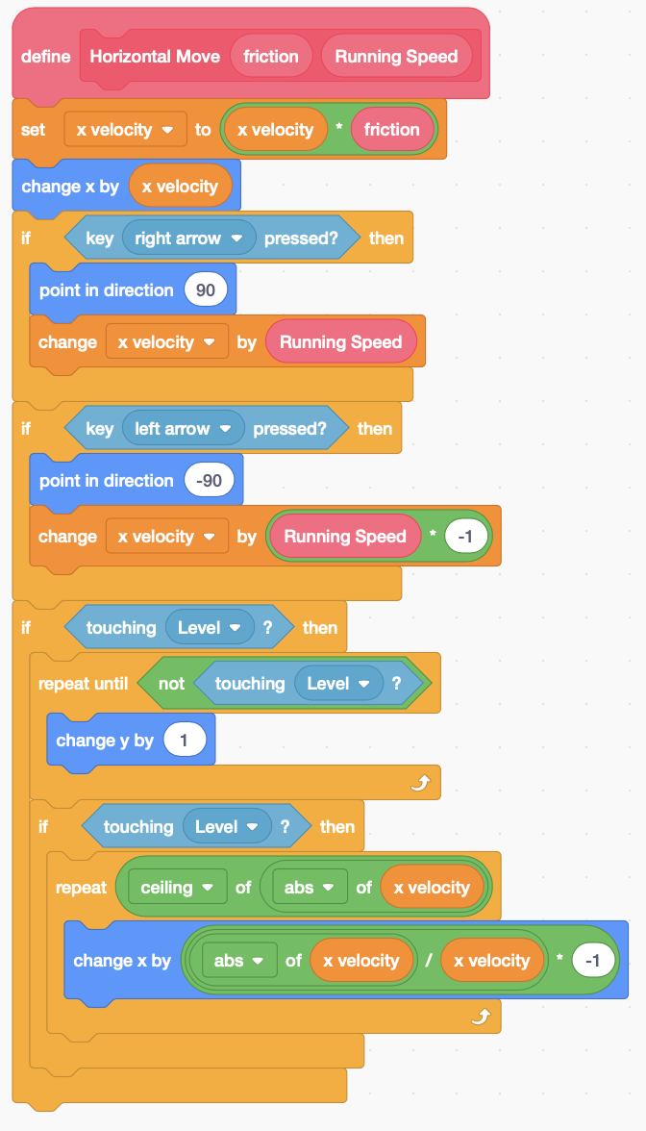

**用确定次数的loop可以避免**

**全是背景时sprite持续下落出窗口**

**Falling, v<0, |v|/v=-1, y=y+1**

**Up going, v>0, |v|/v =1, y=y-1**

**XY Movement**

Using not touch Sprite to control y movement.

The level set as Sprite.

只有一关

## **Horizon and vertical, levels set as Backdrop**

Since the levels are displayed as backdrop, so use touch color to control.

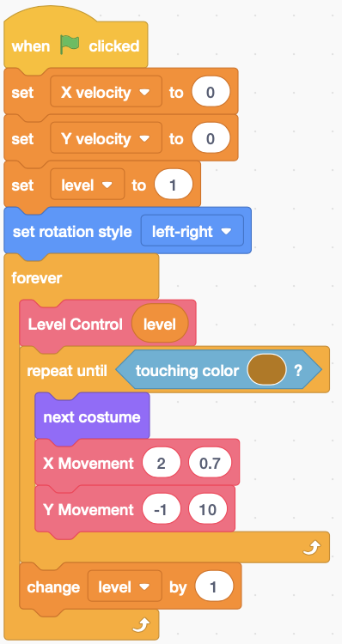 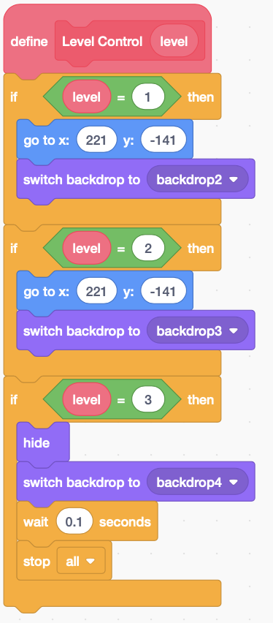 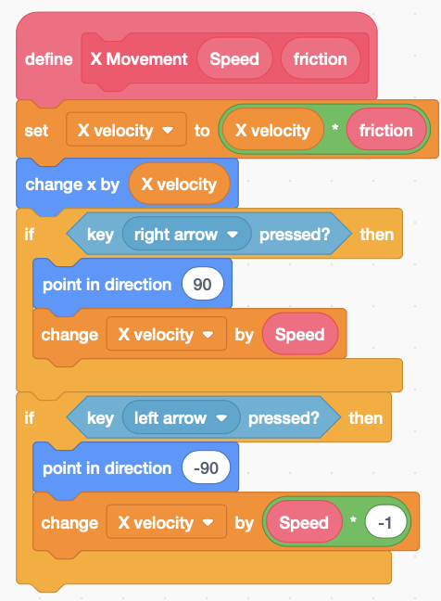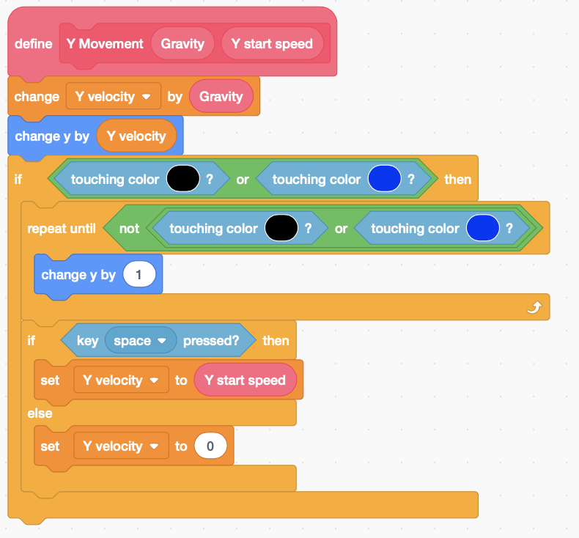

$$\left\{\begin{aligned}\frac{\left|v\right|}{v}=1, v>0 \\ \frac{\left|v\right|}{v}=-1, v<0\end{aligned}\right.$$

$$ds=v_{t}dt$$

$$2v_{t}dv_{t}=2ads$$

$$v_{t}dv_{t}=ads$$

$$v_{t}adt=ads$$

$$ds=v_{t}dt$$

$$v_{t}=v_{t}+at$$

$${dv}_{t}=adt$$

$$v_{t}^{2}-v_{0}^{2}=2as$$

## **Sprite shows at desired level**

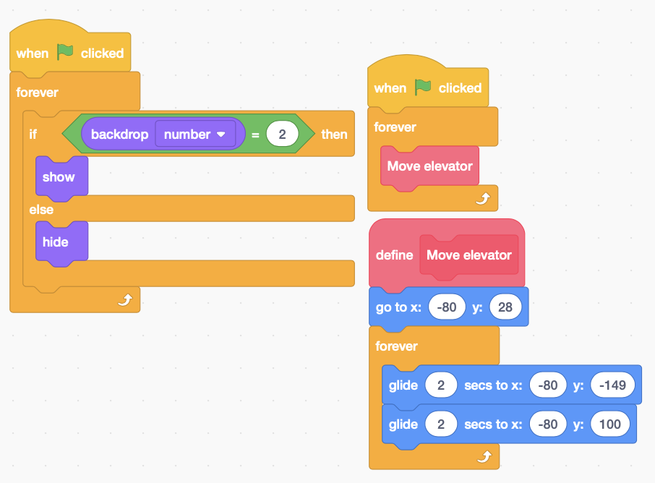

## **Final Movement Project**

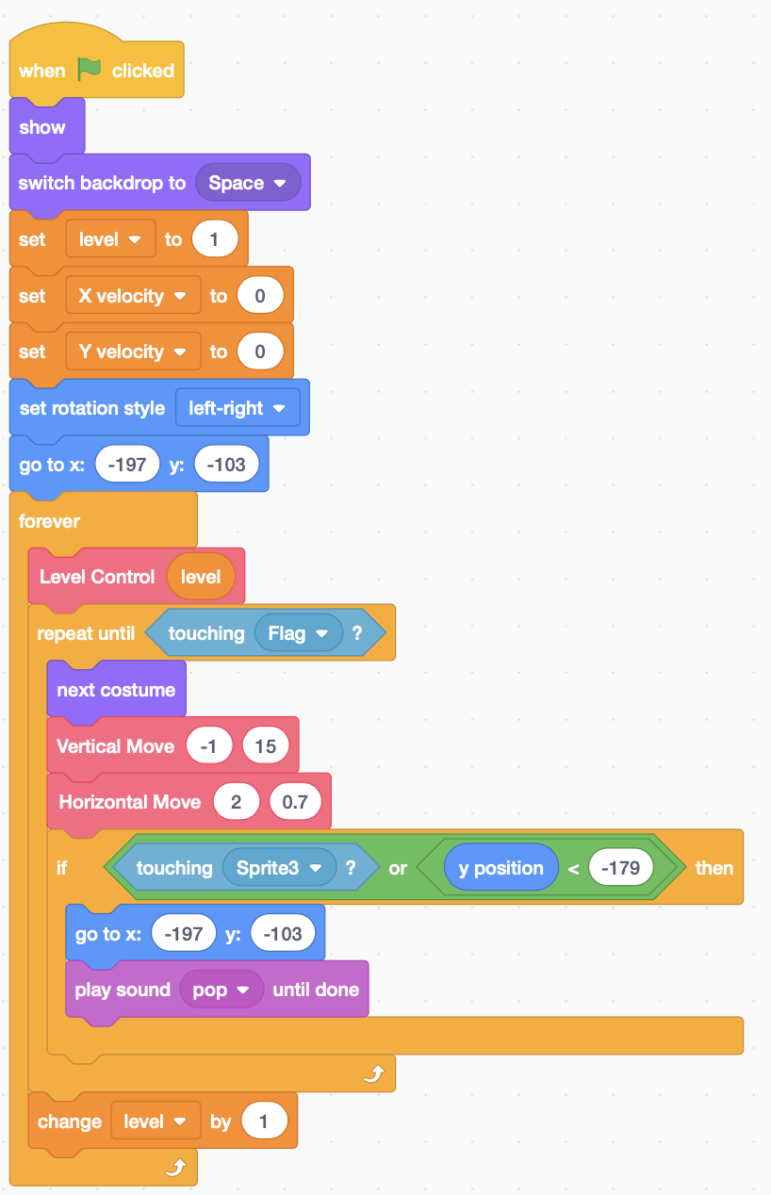 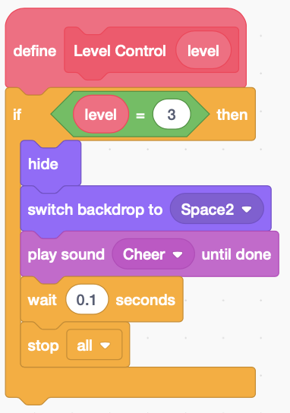 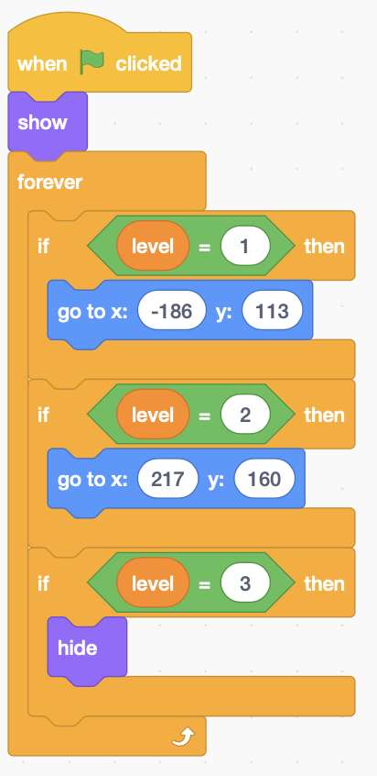

**Flag**

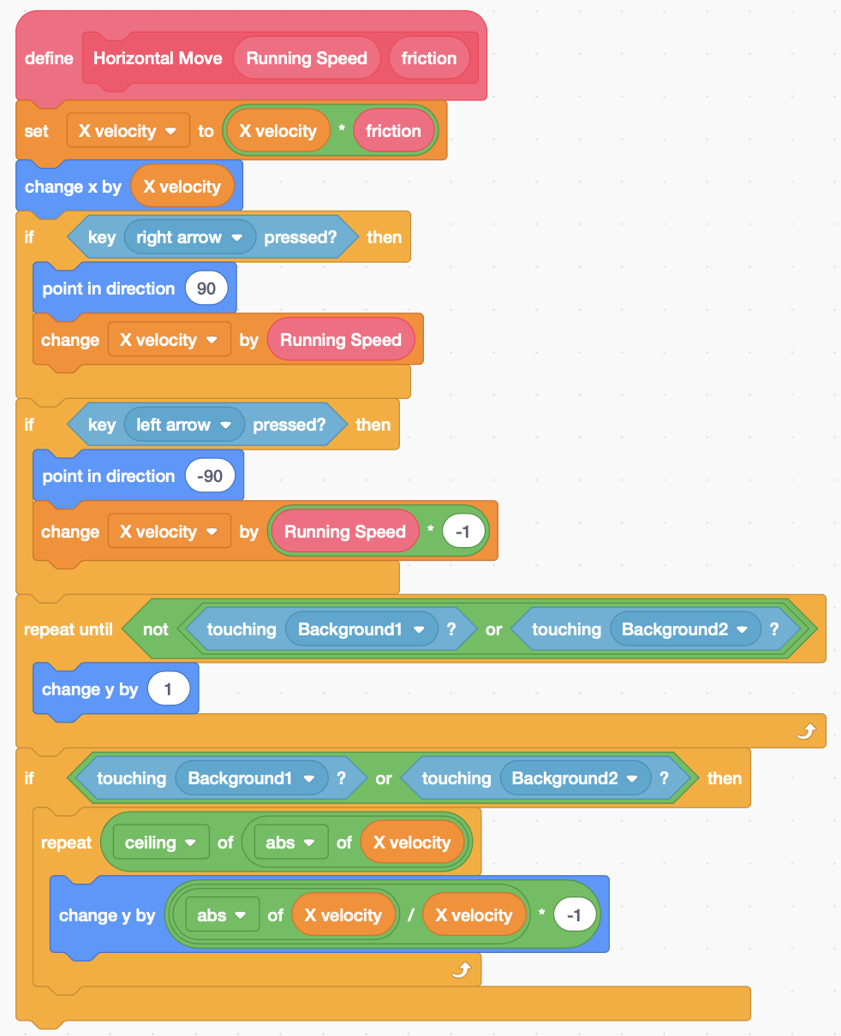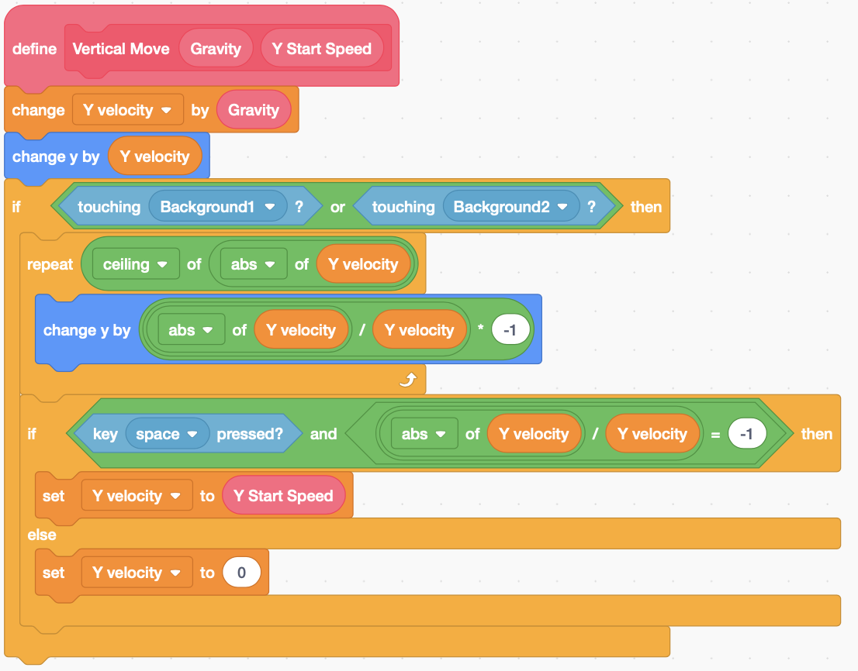

## **Projectile Motion (Parabolic Motion) / Fruit Ninja**

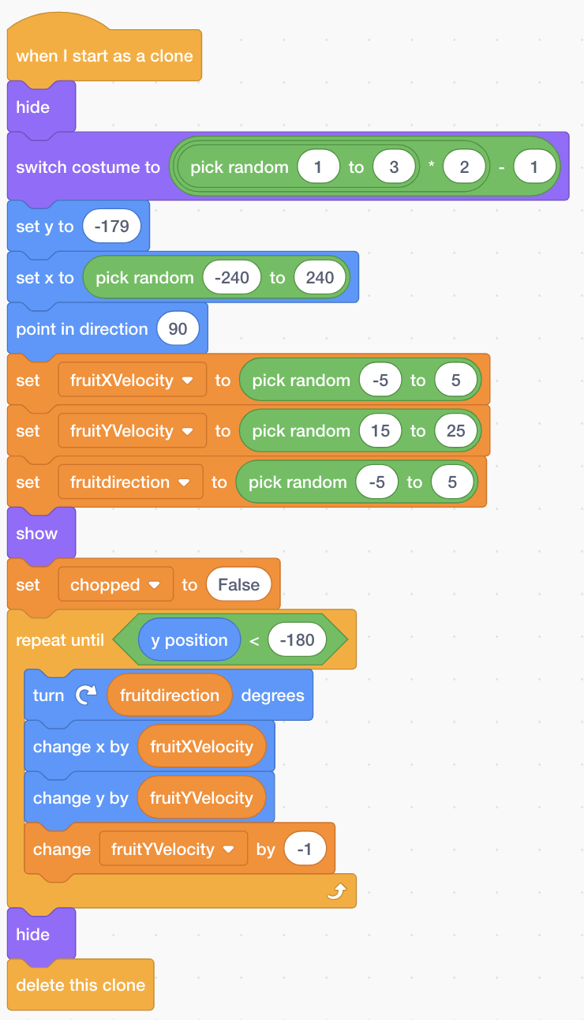

## **Fight coronavirus \ Go to random without inside sprite**

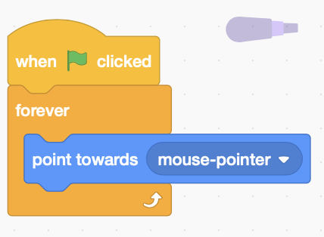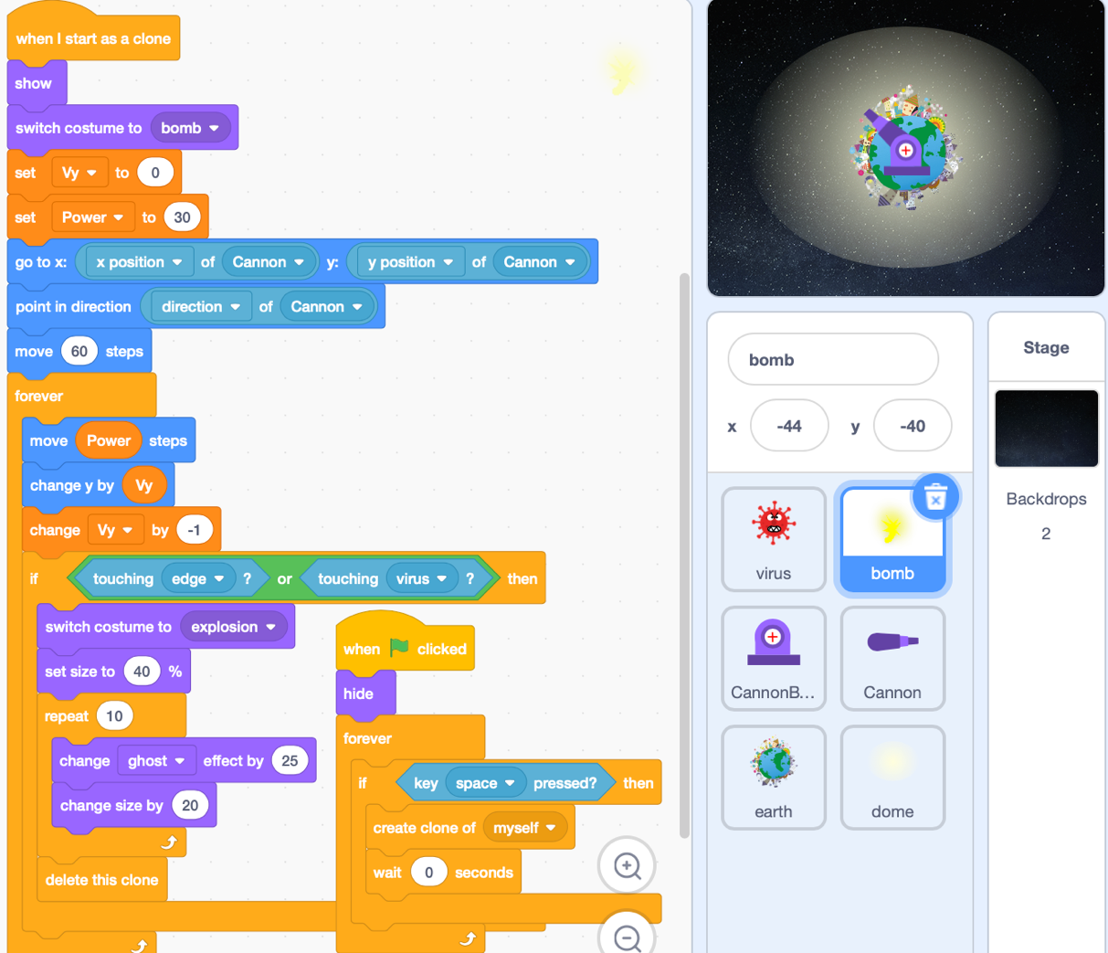 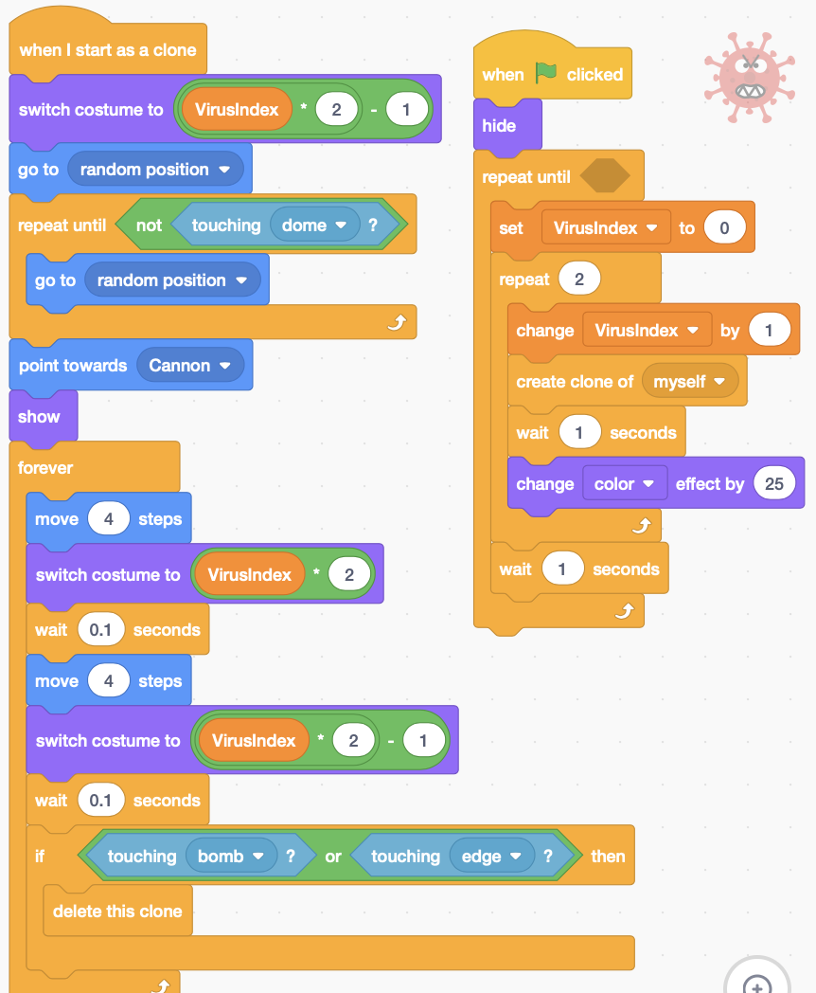

## **T-Rex (Moving Ground / Render Number)**

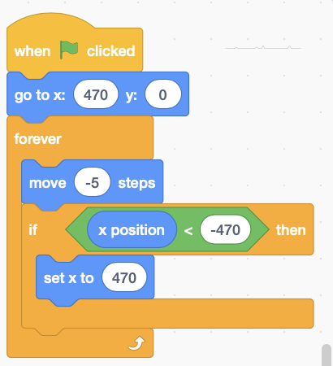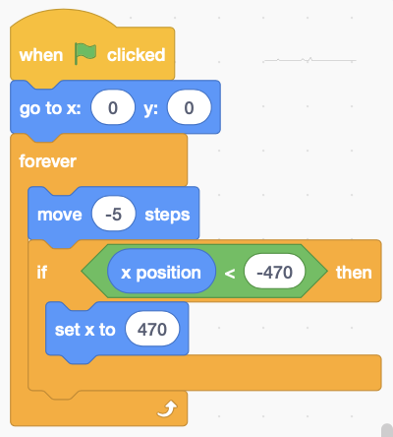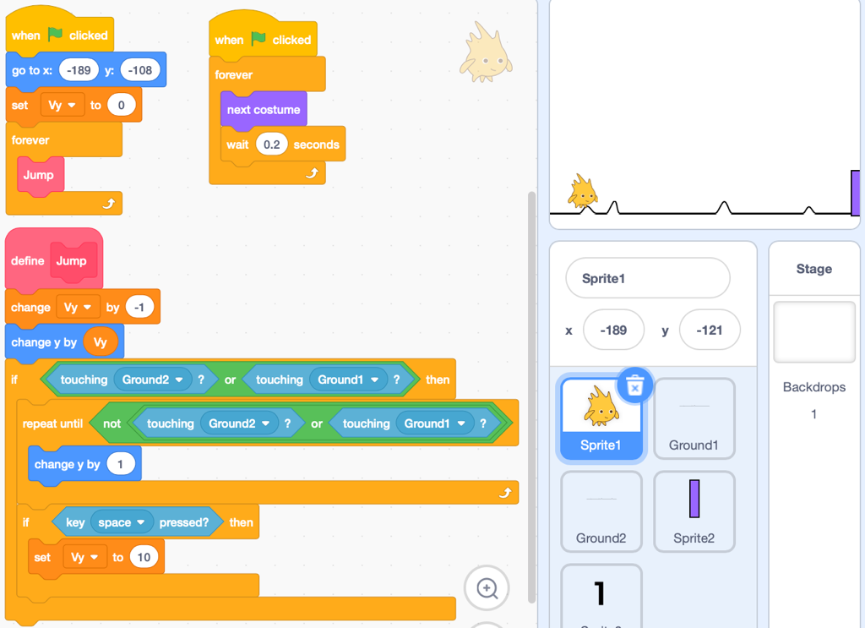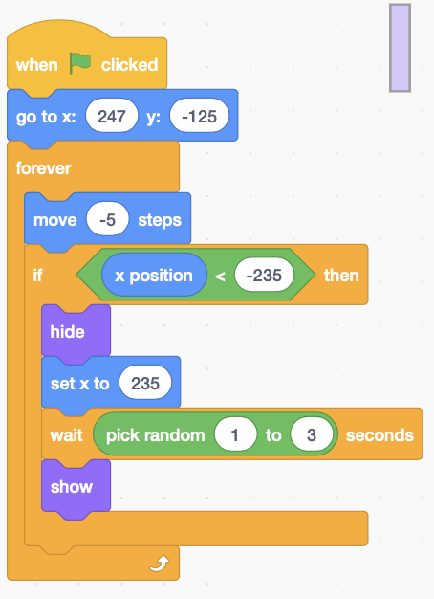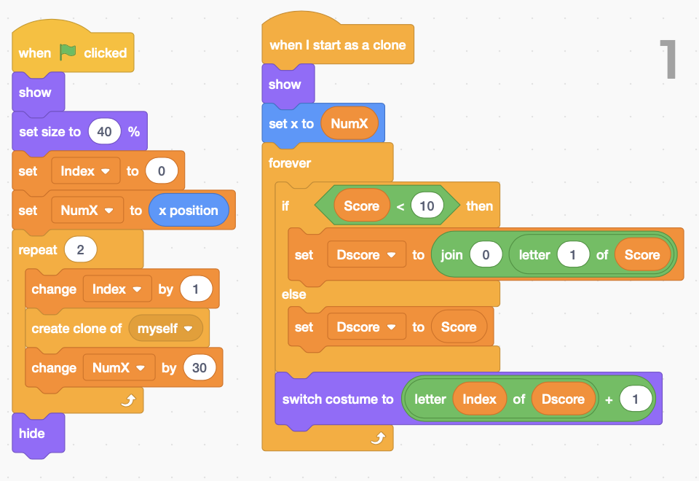

**Moving Ground**

## **Parking Cars**

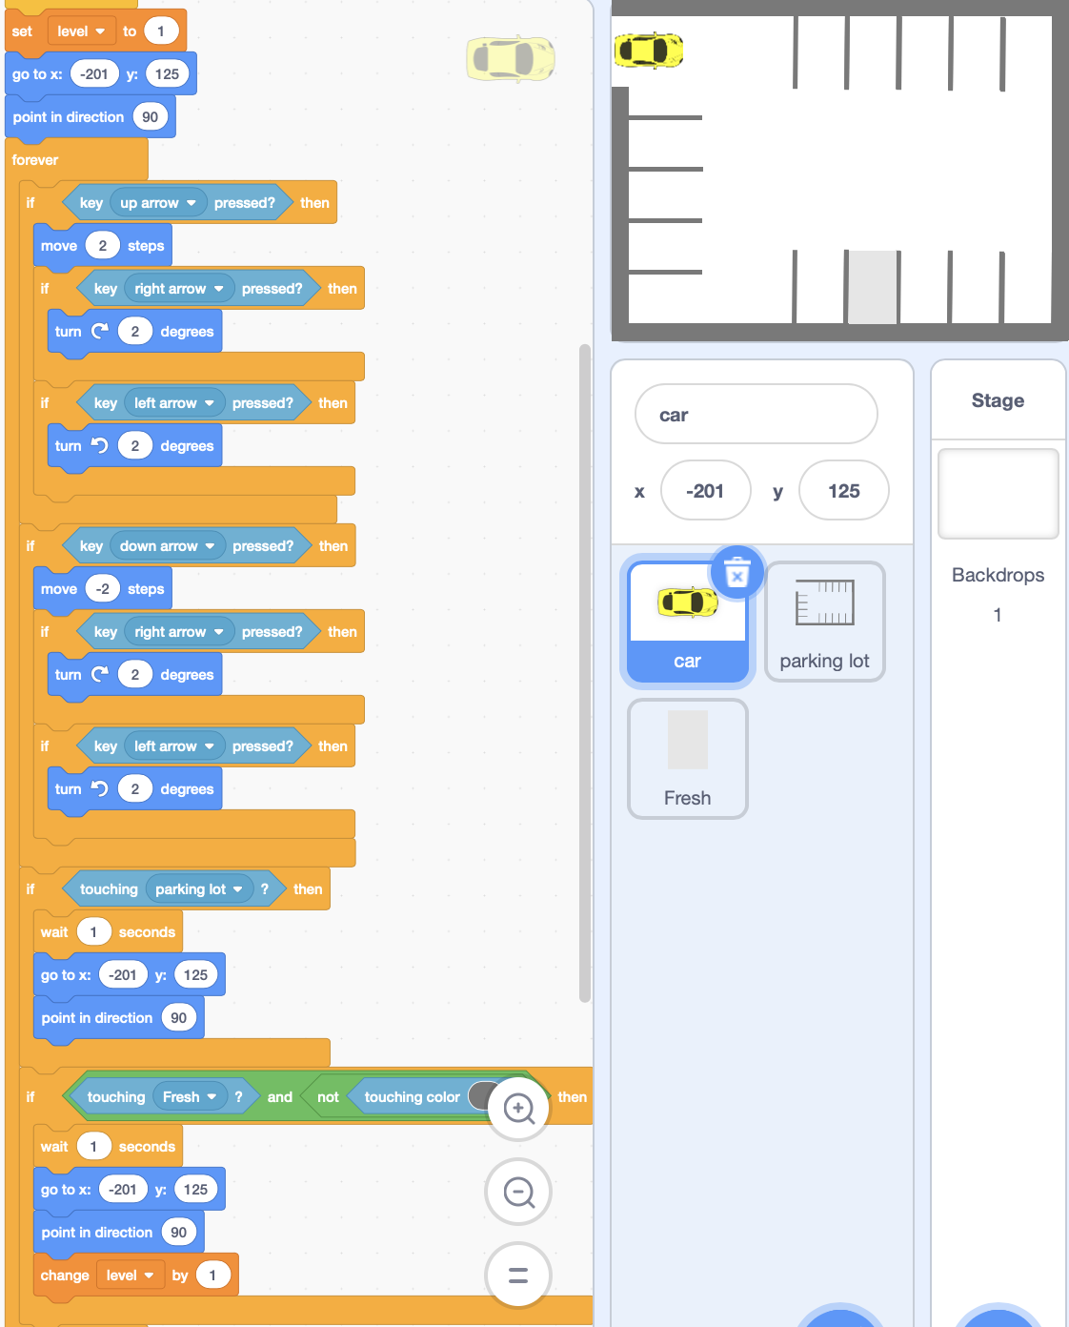

## **Bouncing movement**

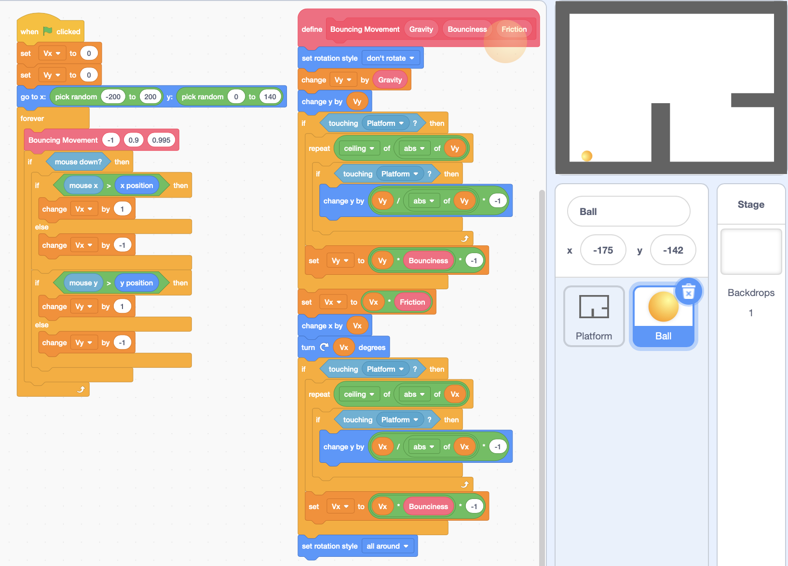

## **Brick block/ Bouncing/ make clone**

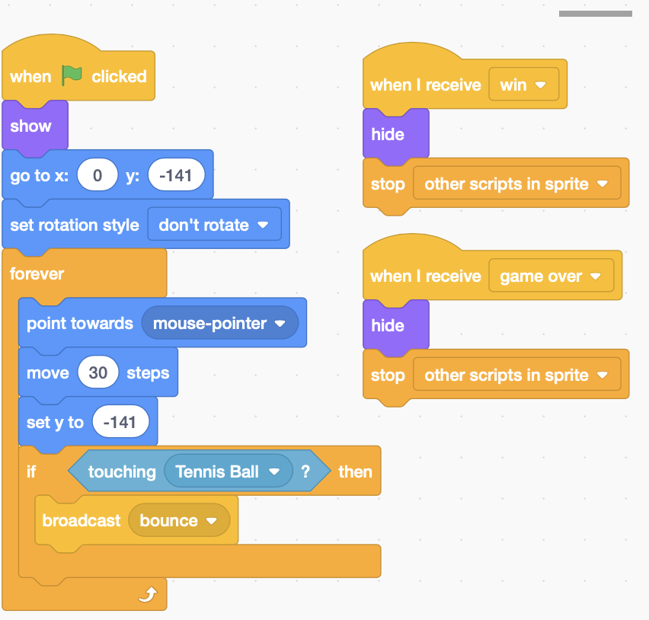 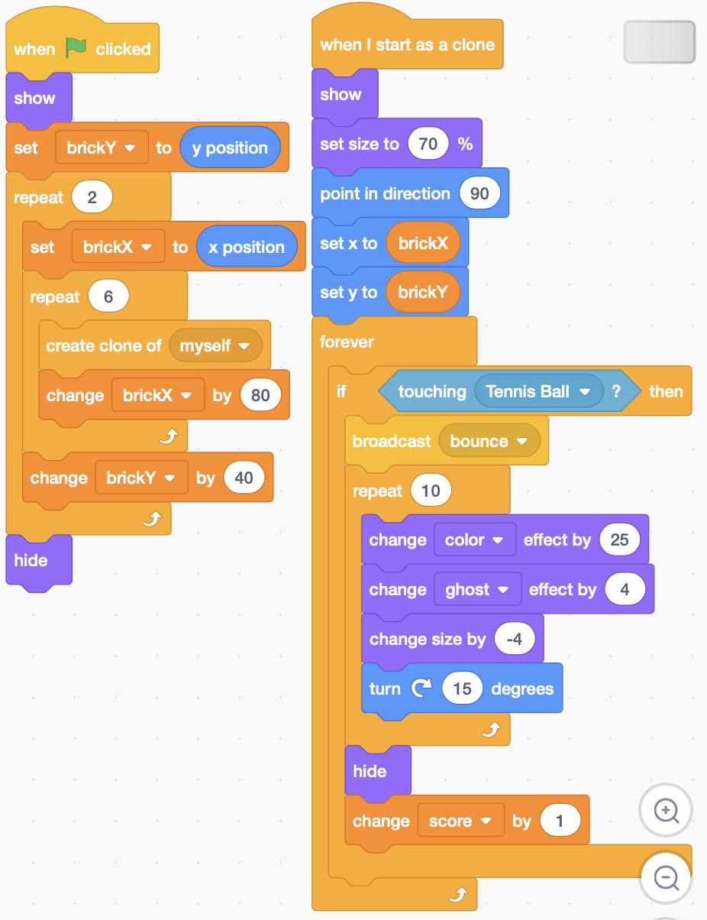

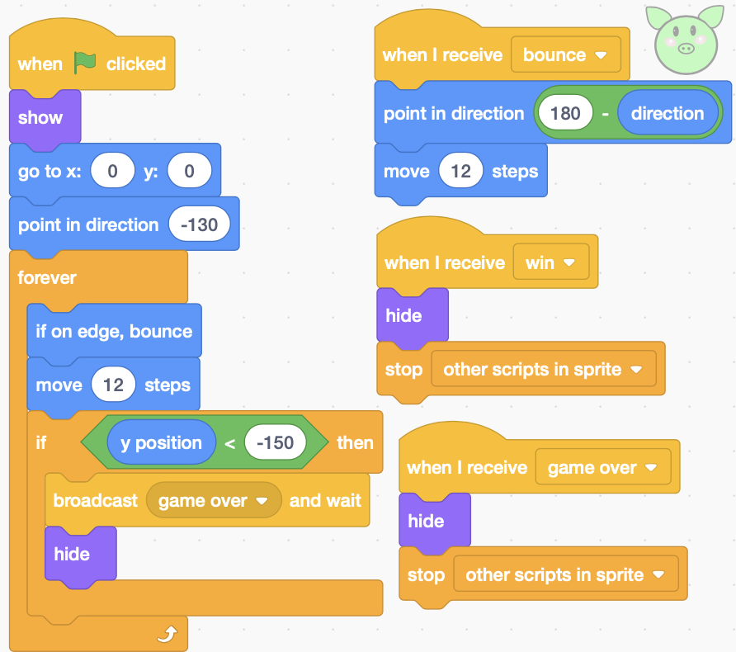

## **Swimming Fish**

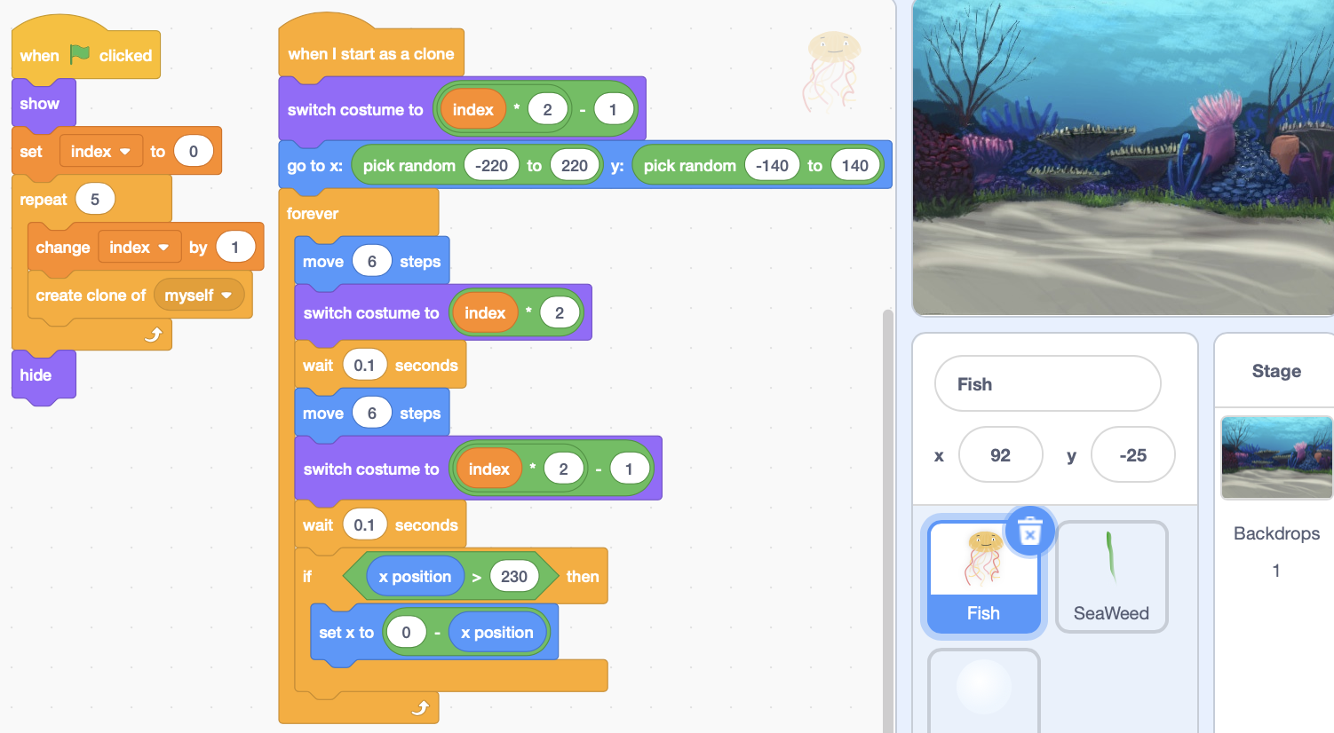

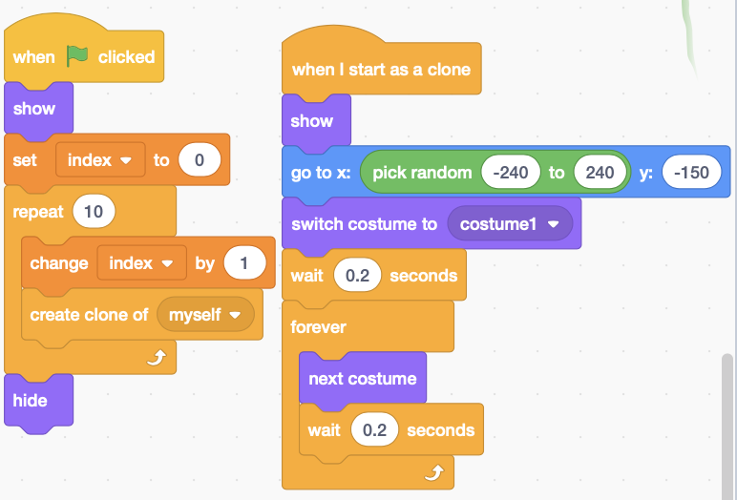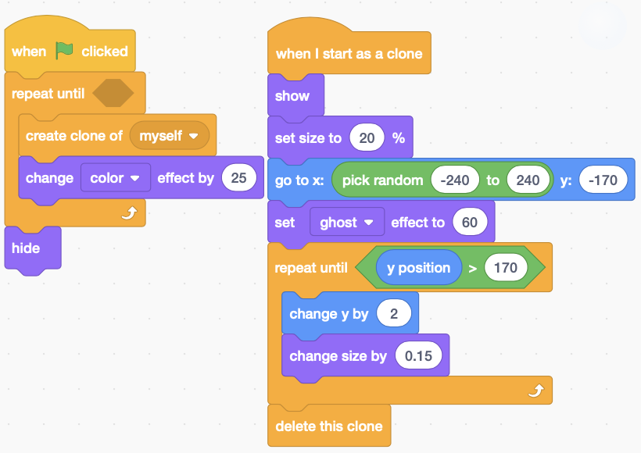

# **Pac Man Game**

## **Pac Man I**

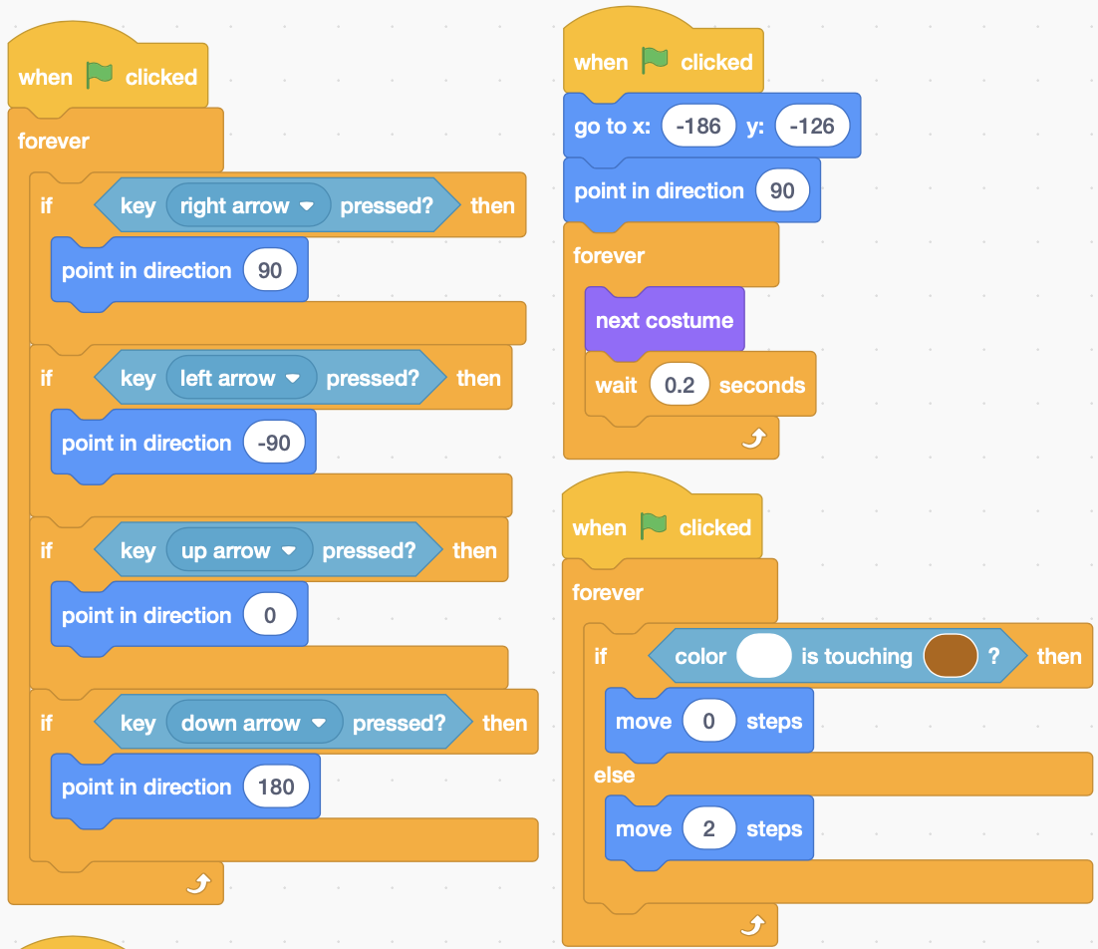 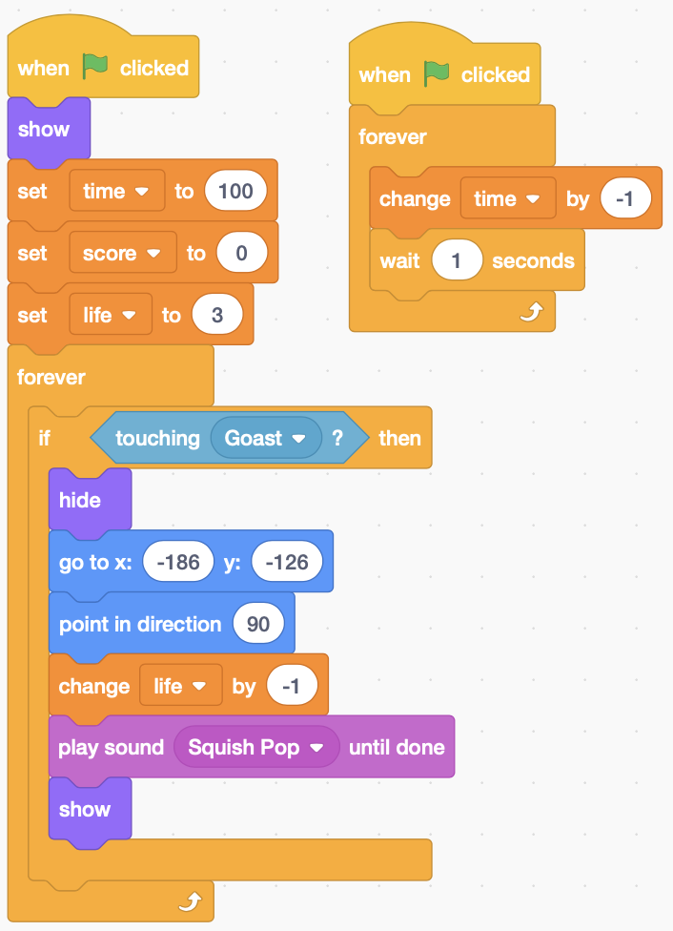

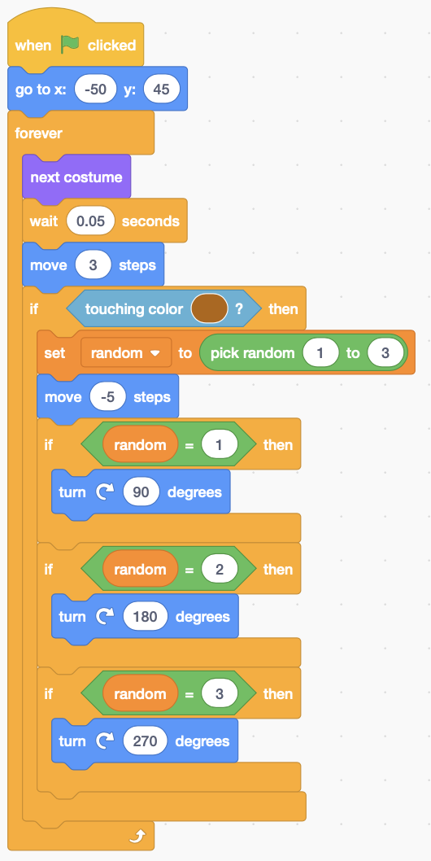 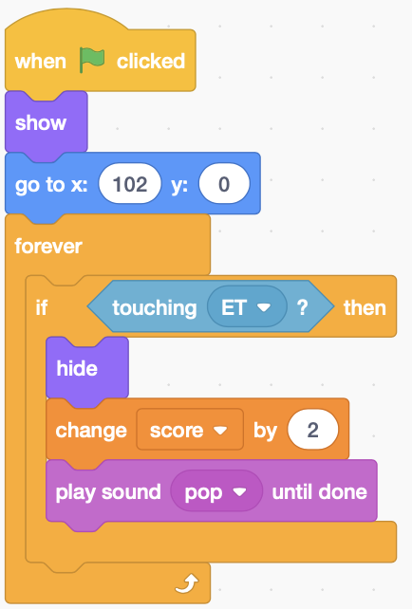 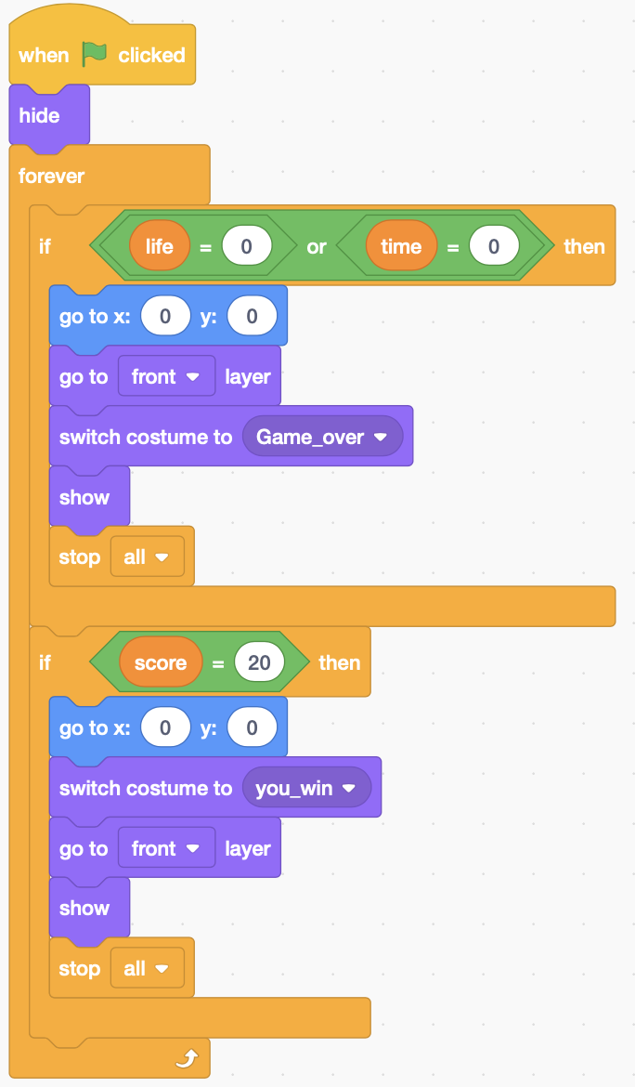

**Glost**

**Lucky Bean**

**Win / Game Over**

## **Pac Man II**

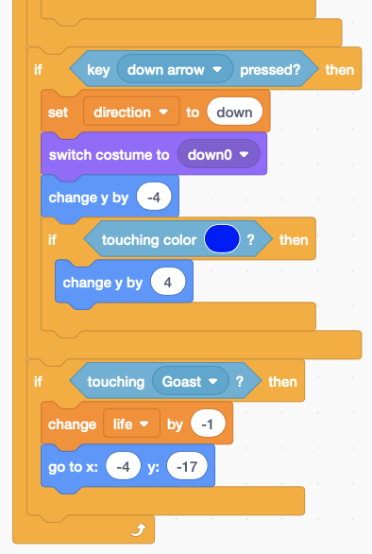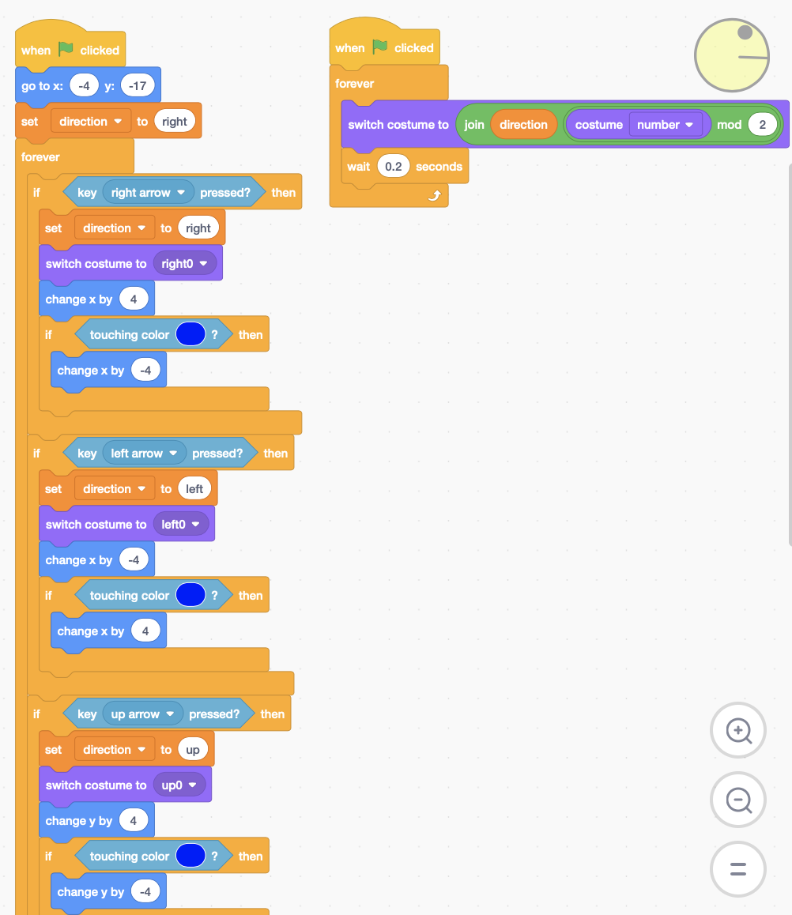 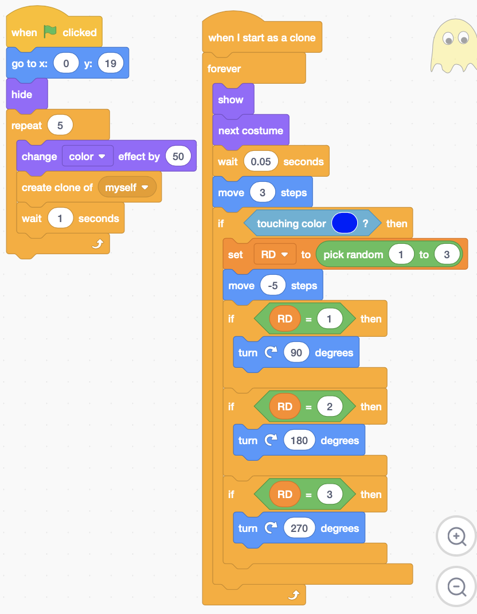

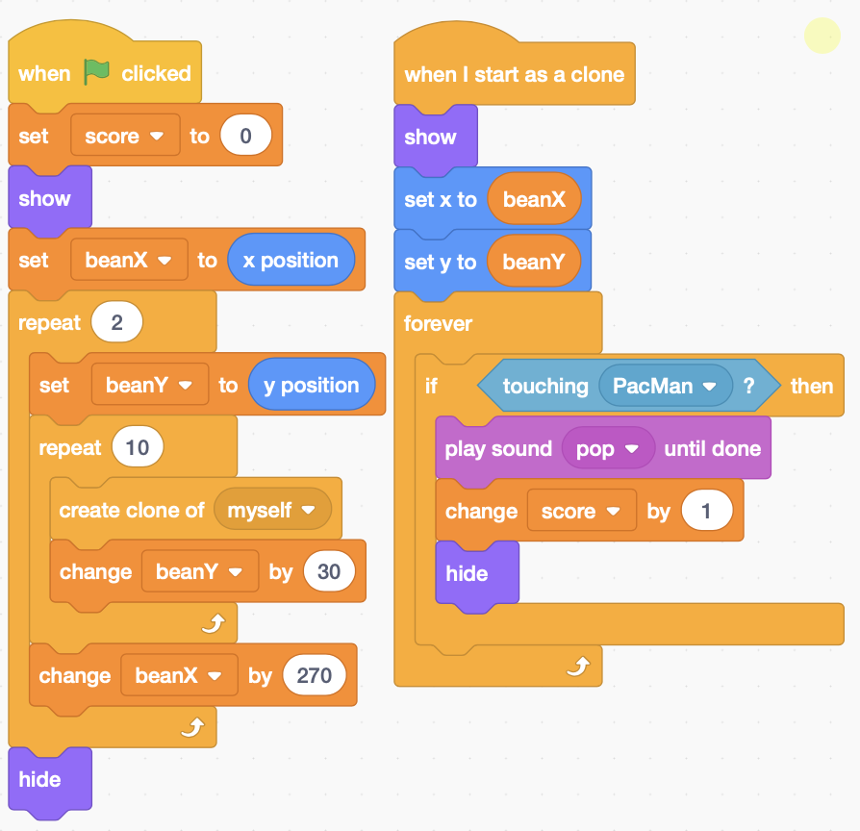 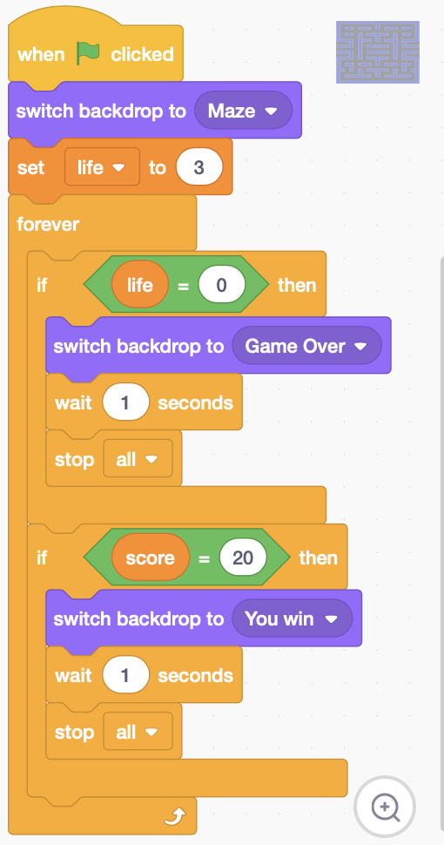

## **Bomber man**

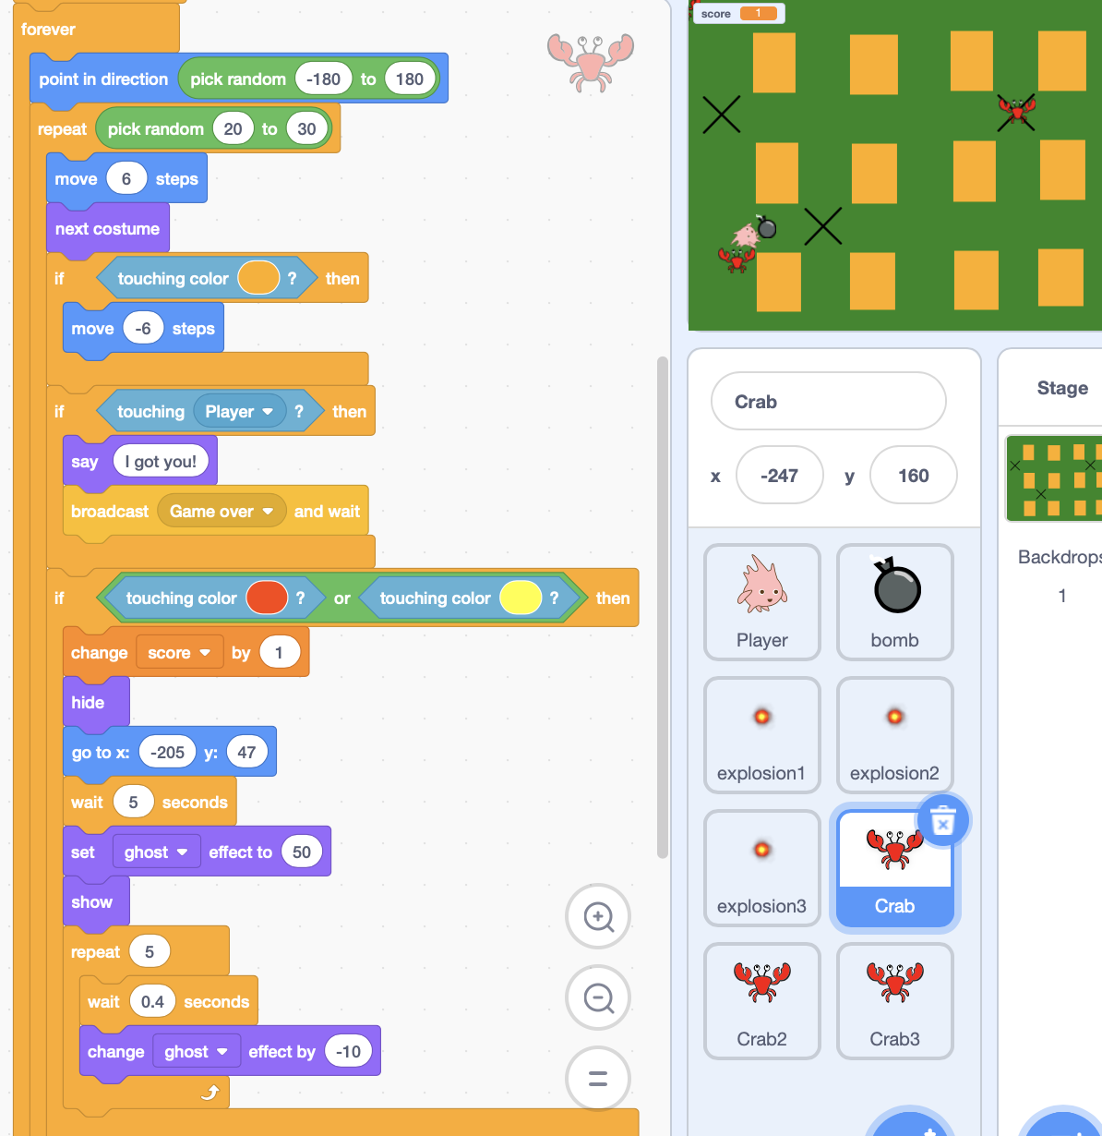 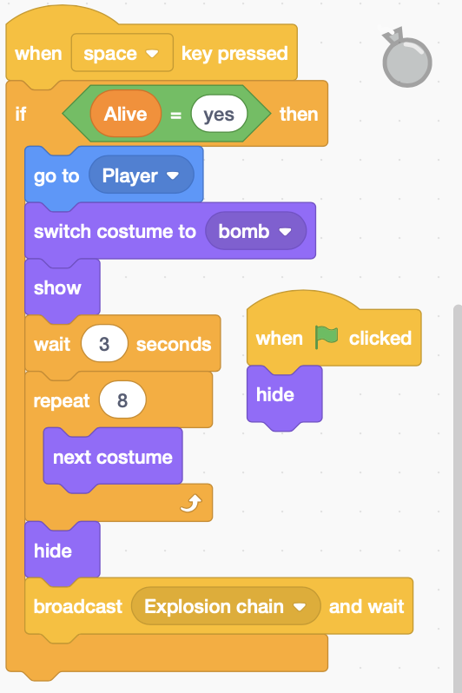

**Put a bomb**

**If die, then go to initial position and fade in**

# **Scrolling Platform**

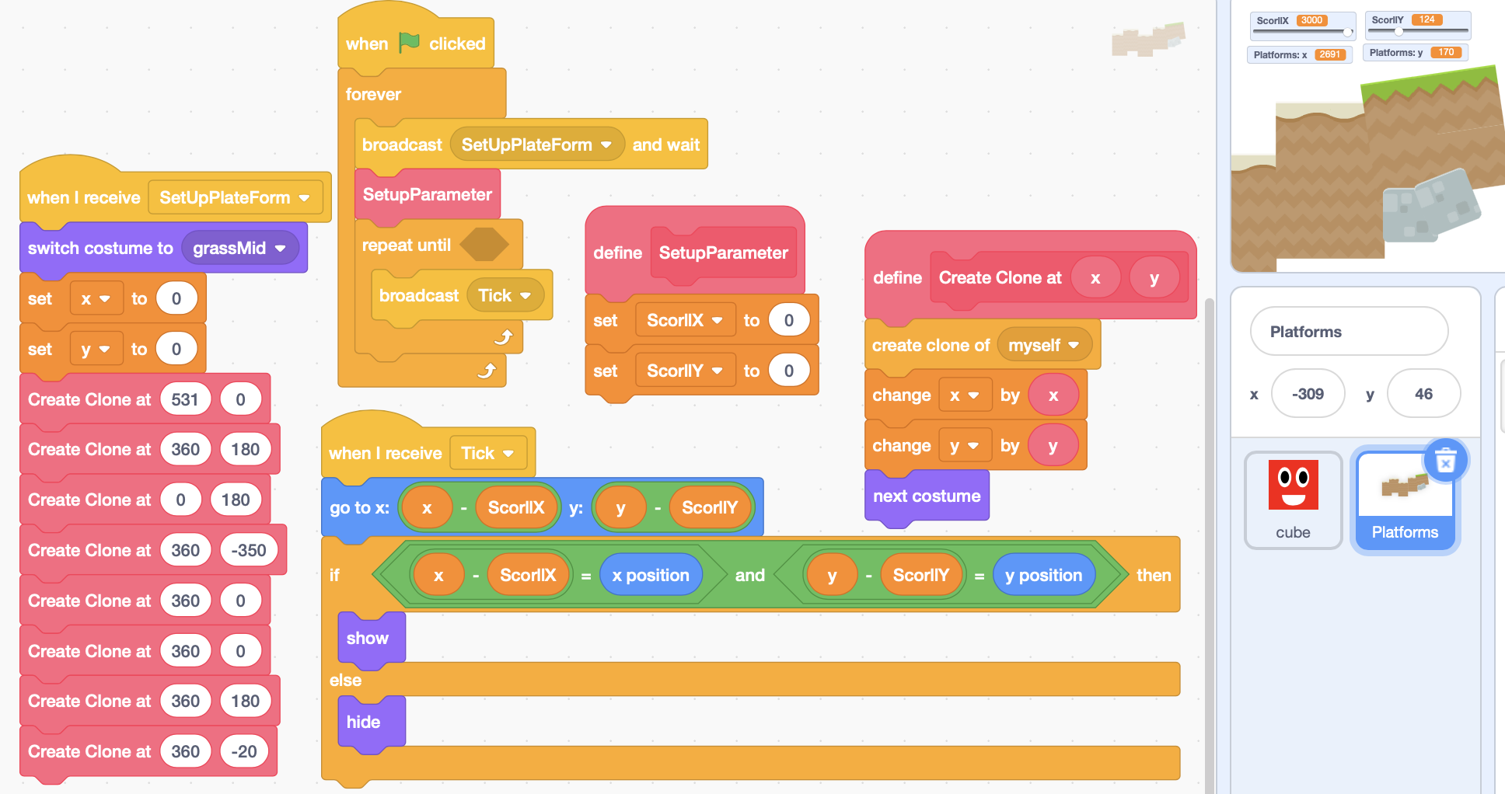

**ScorllX and ScorllY are global variables.**

**The first Platform is created at 0,0. Then it will created at (x, y). Every time, the x is changed by x and by y. So the range of x is the sum of x in create clone at x. In this case, the range of x is (-240, 2691).**

[**https://en.scratch-wiki.info/wiki/Scrolling_Platformer_Tutorial**](https://en.scratch-wiki.info/wiki/Scrolling_Platformer_Tutorial)

## **Scrolling Player**

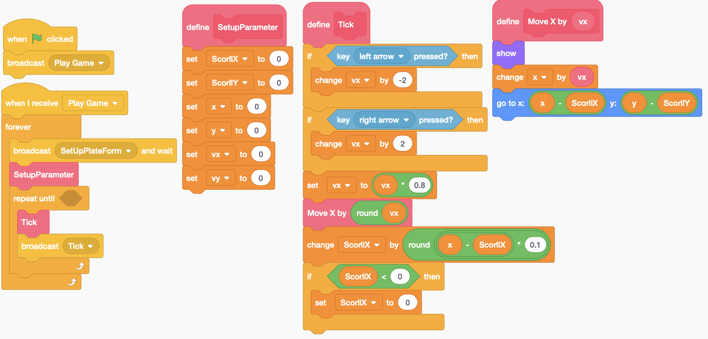

**Change ScorllX by x-ScorllX**

**Change x by vx**

**0.8 is for friction**

**Change x by vx, change ScorllX by x-ScorllX, go to x-ScorllX.**

**Cube Dash Game**

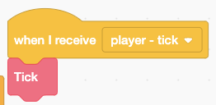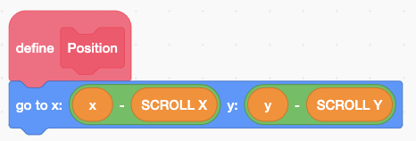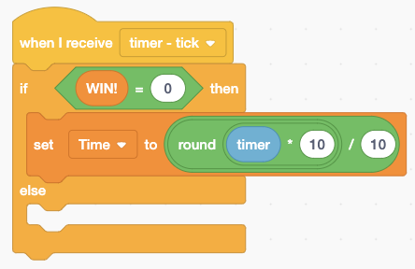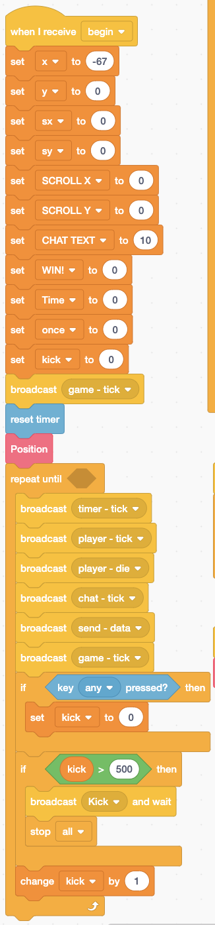 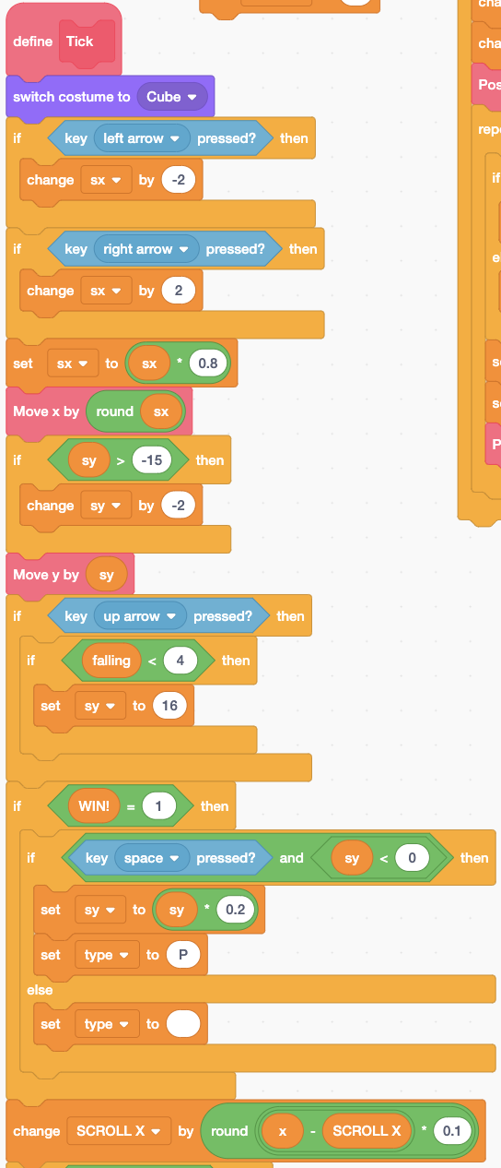 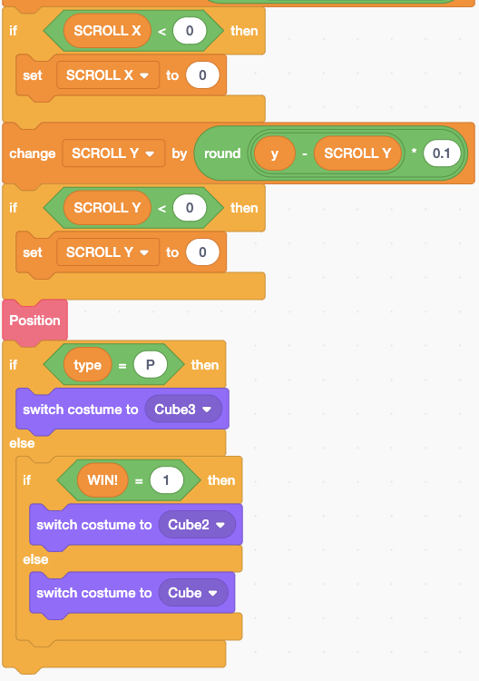

**Player**

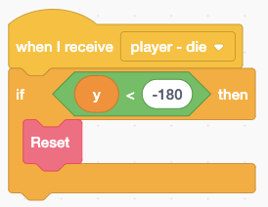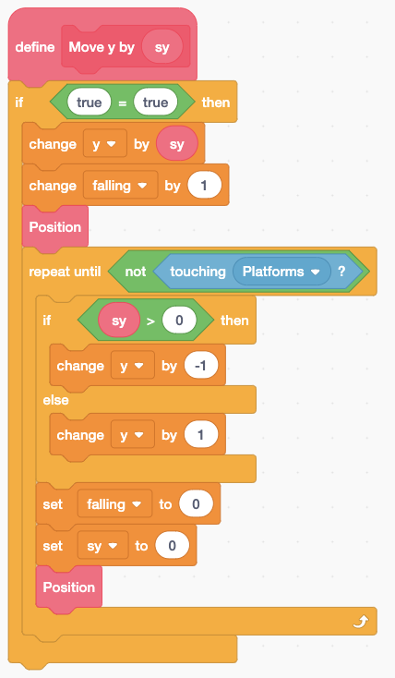 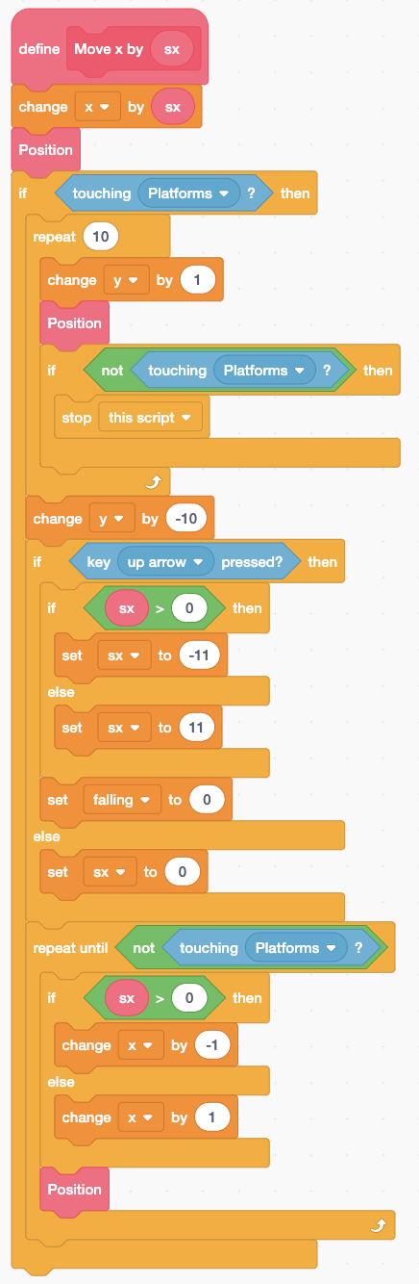 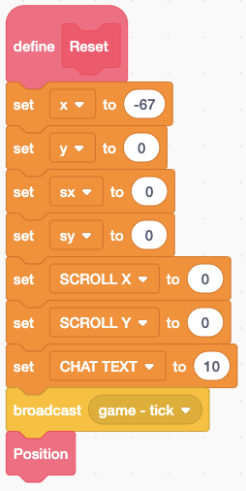

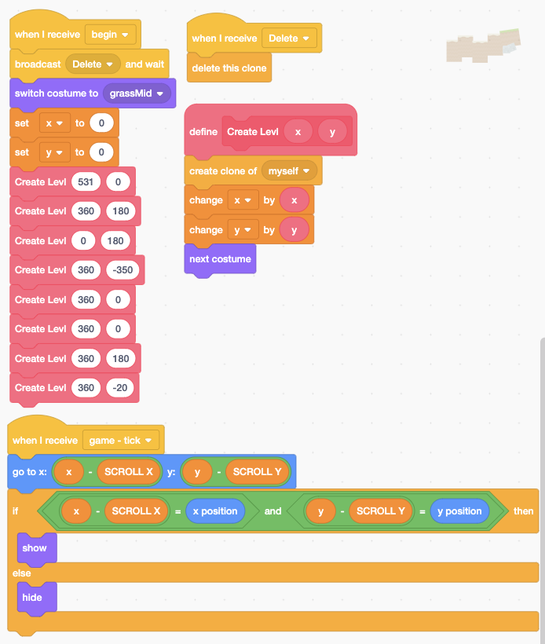 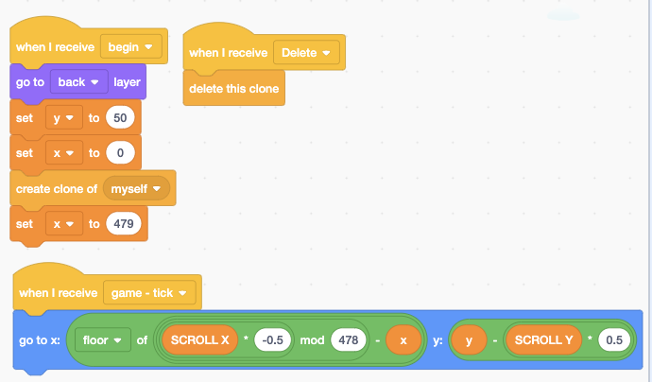

**Platform**

**Cloud**

## **Scrolling Platform Example 1**

**Player**

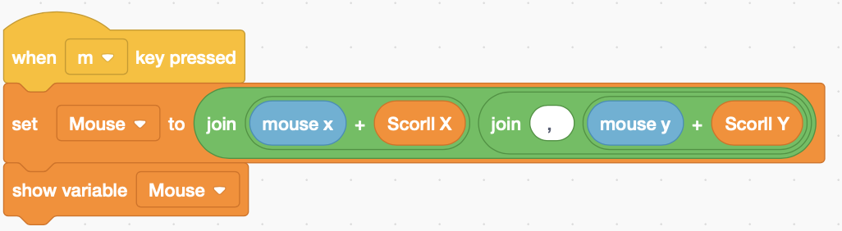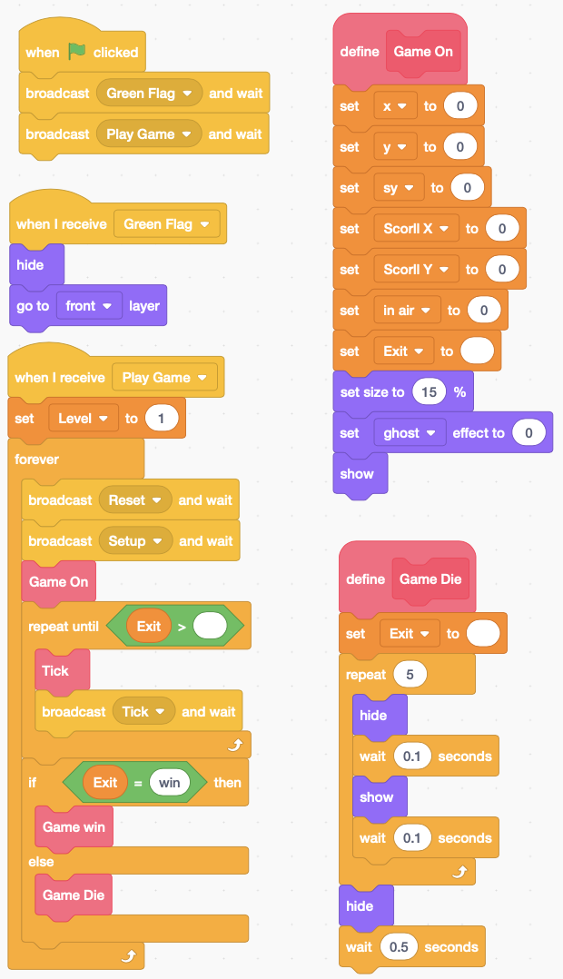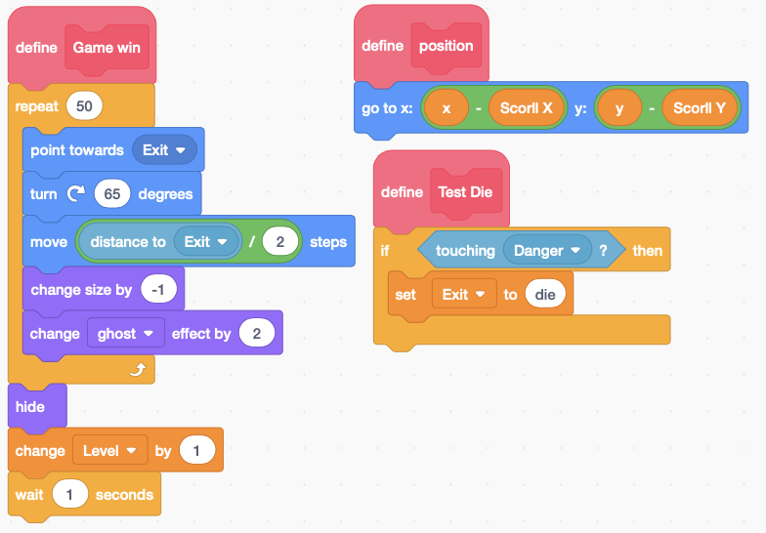

**Get mouse’s coordinate.**

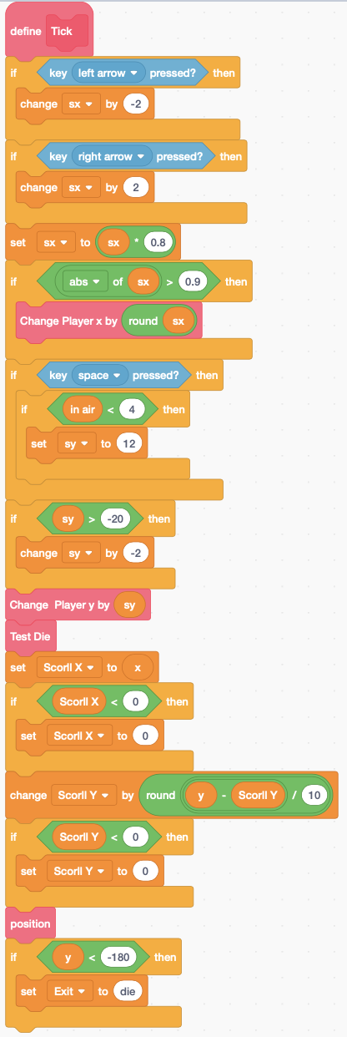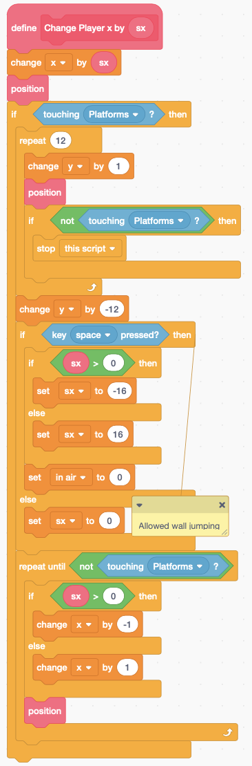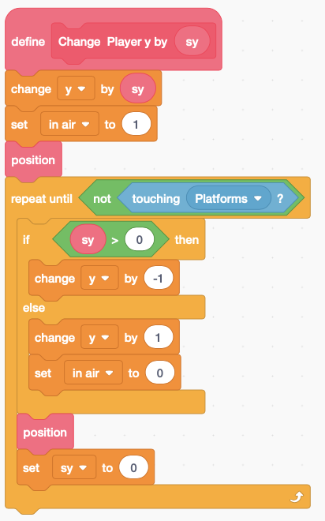

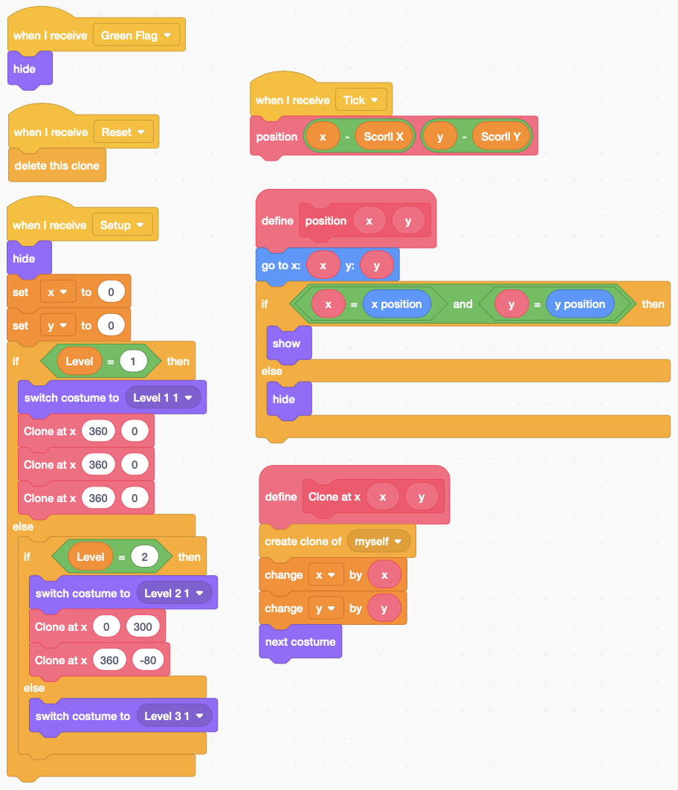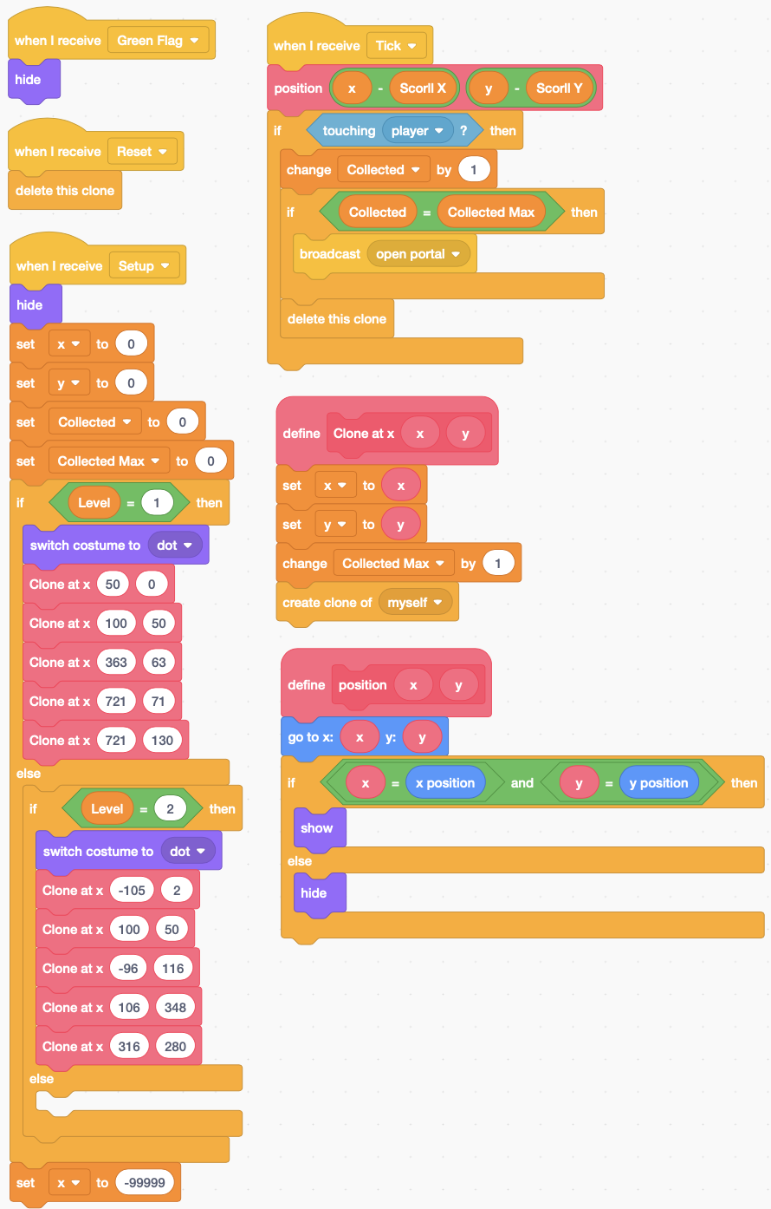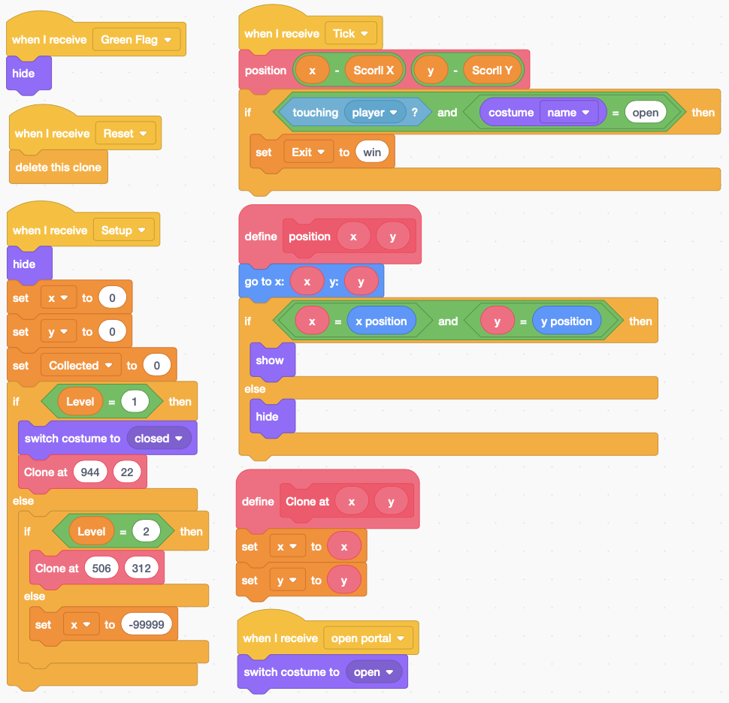

**Platforms**

**Exit**

**Collectables**

# **Scrolling Maze Game**

**Player**

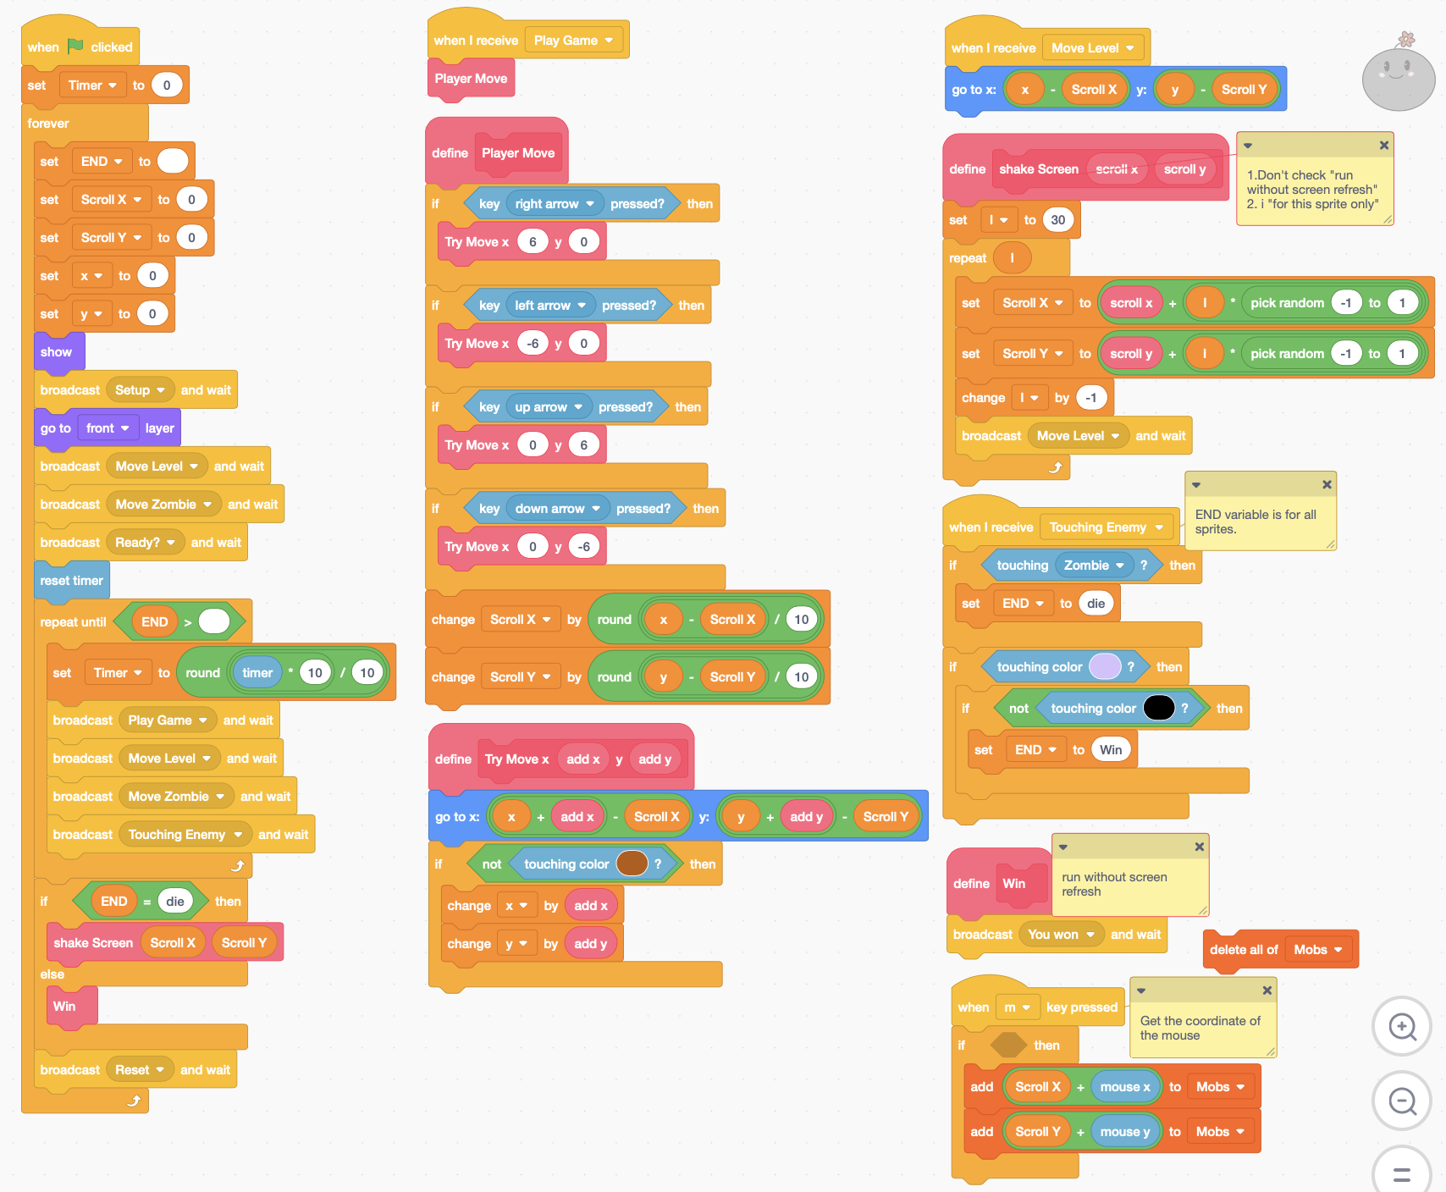

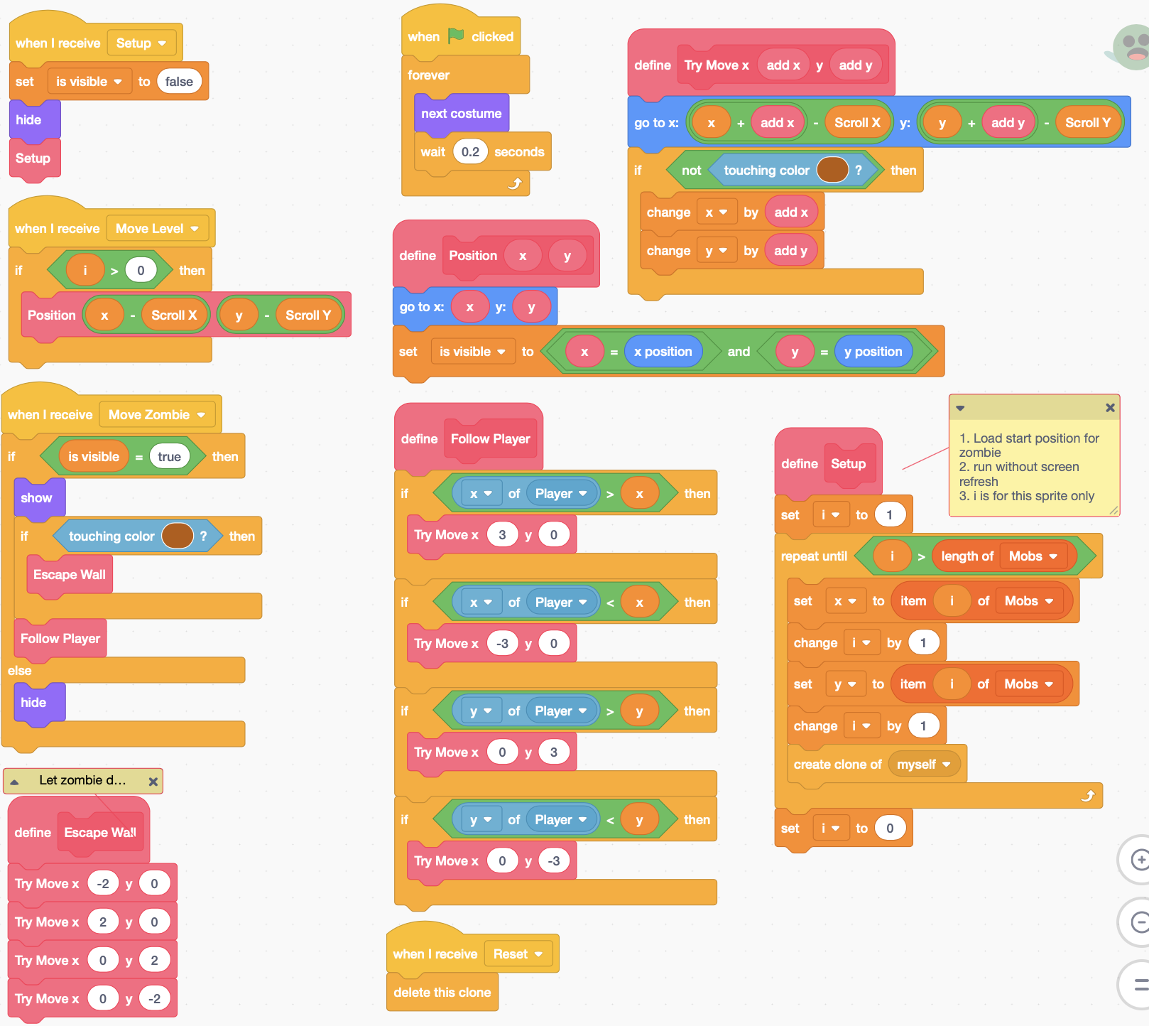

**Zombie**

**Win**

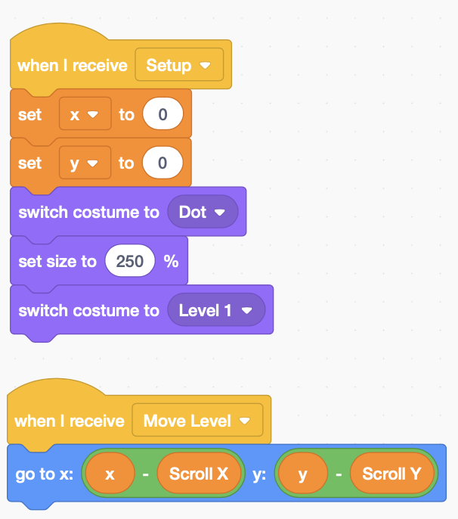 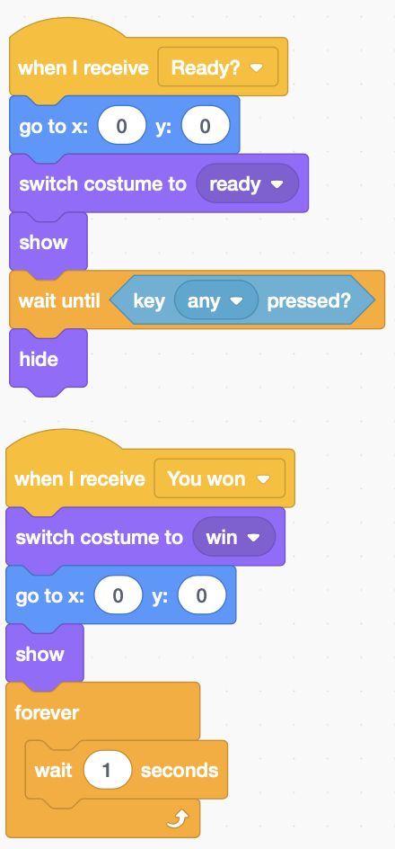

**Platform**

# **3D Effect**

## **3D Moving effect**

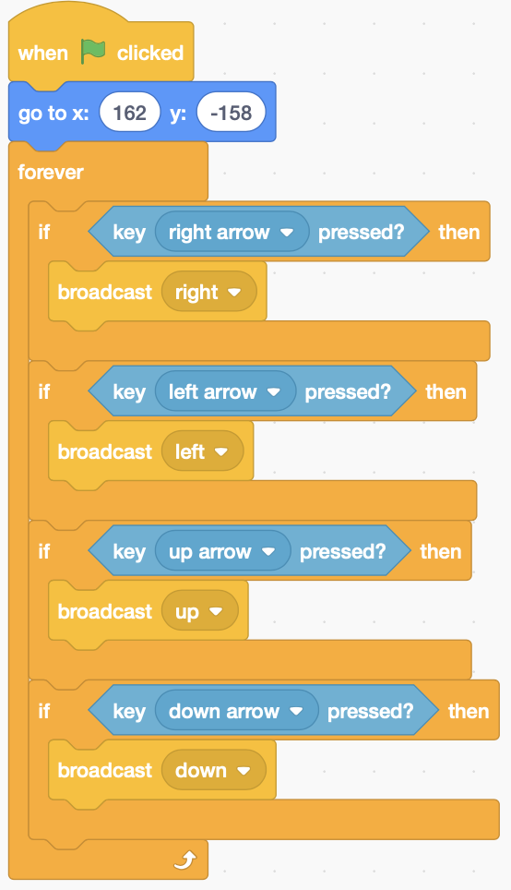 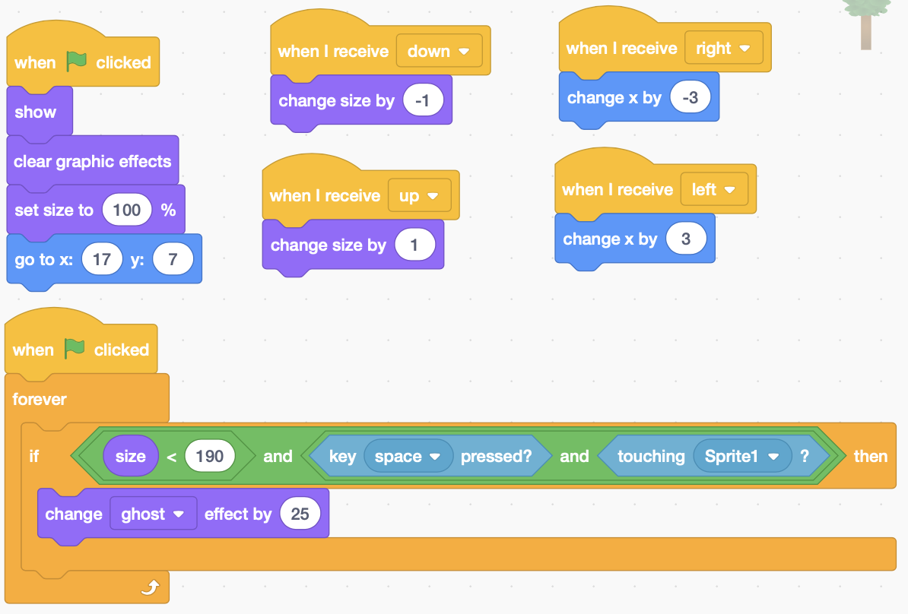

## **3D Cube Moving**

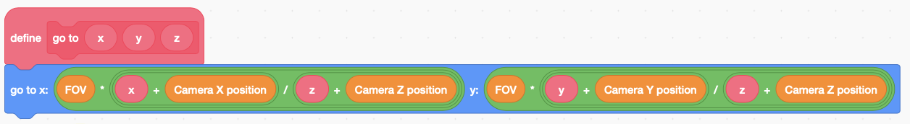

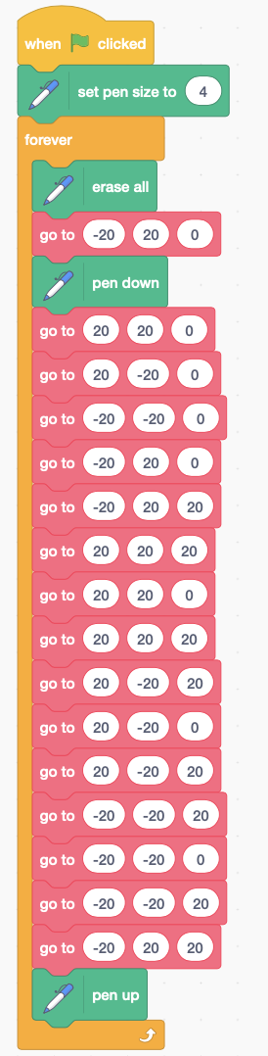

# **Clone sprite operation**

## **Shooting Zombie / clone sprite**

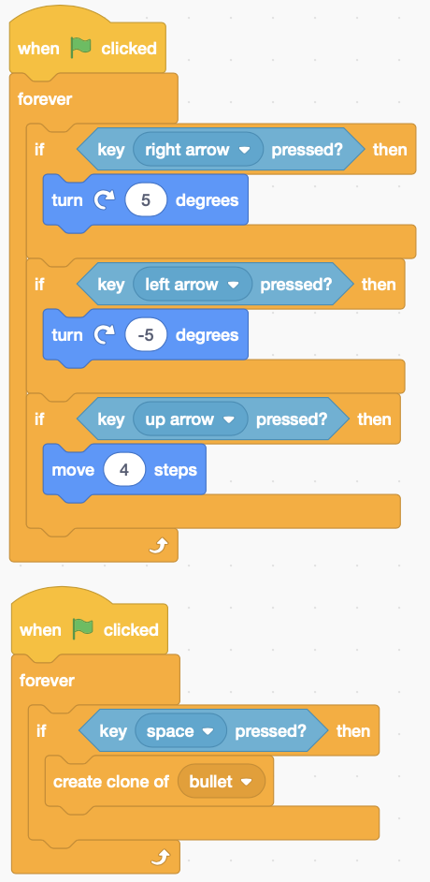 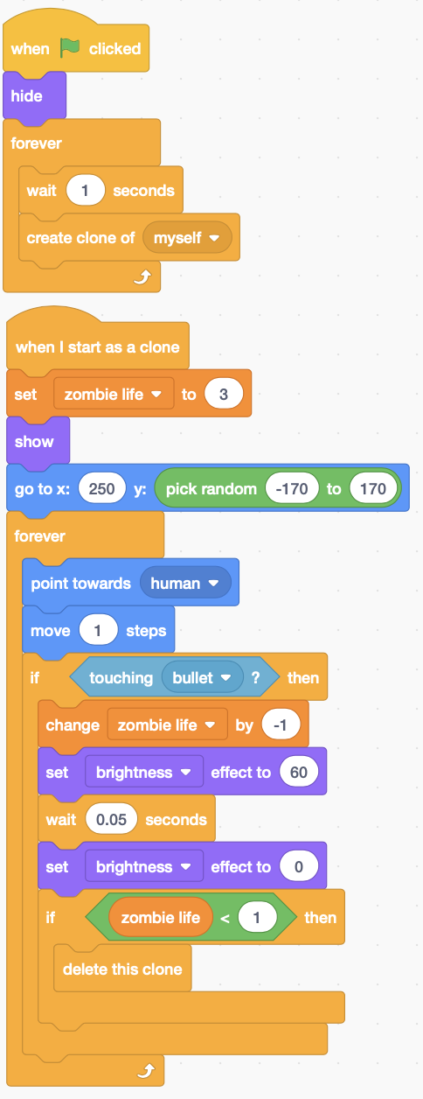 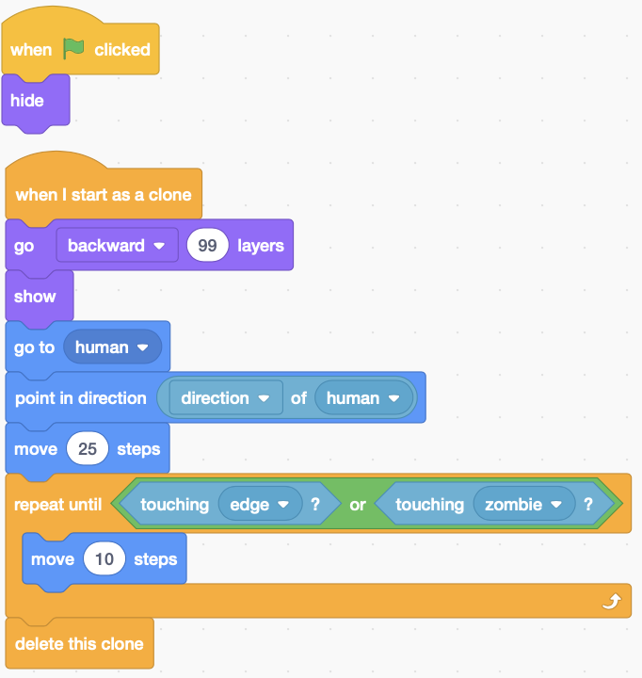

**Bullet**

**Zombie**

**Human**

## **Using List to store Clone direction, X, Y**

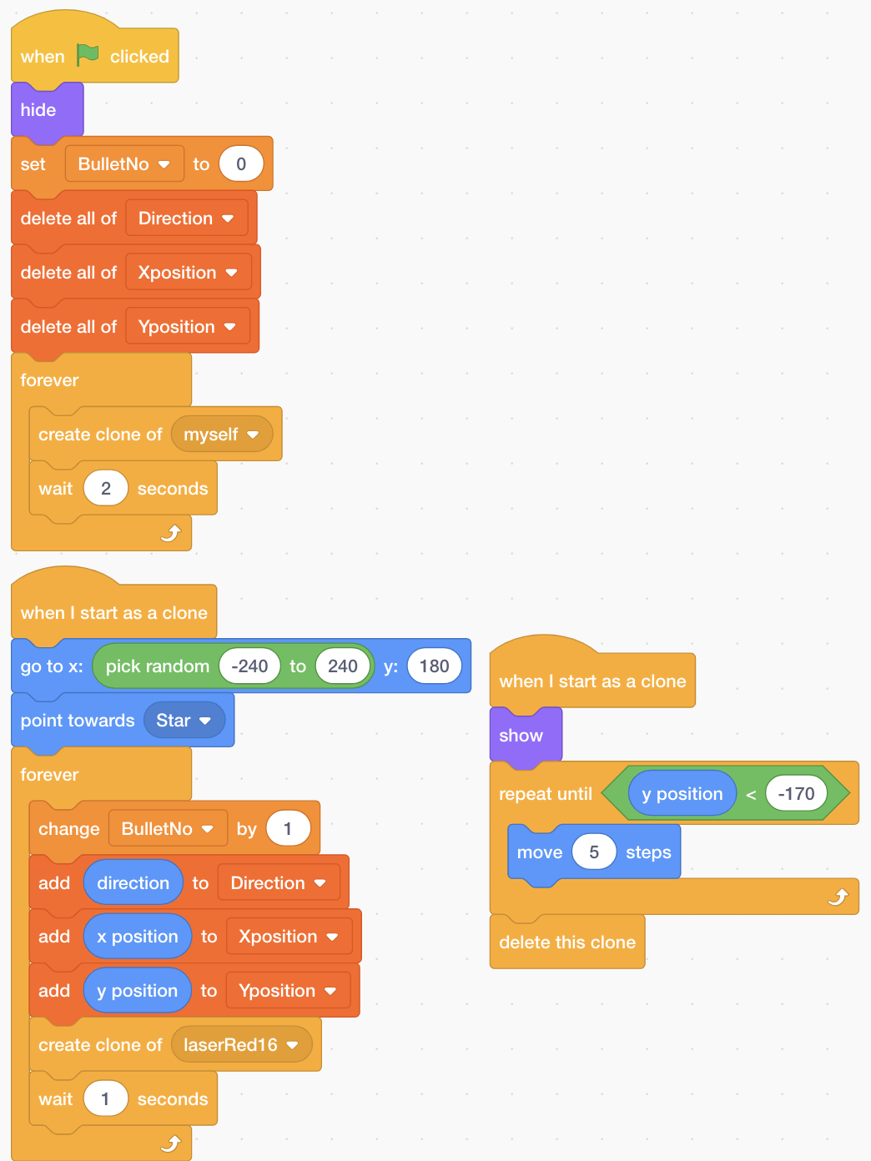 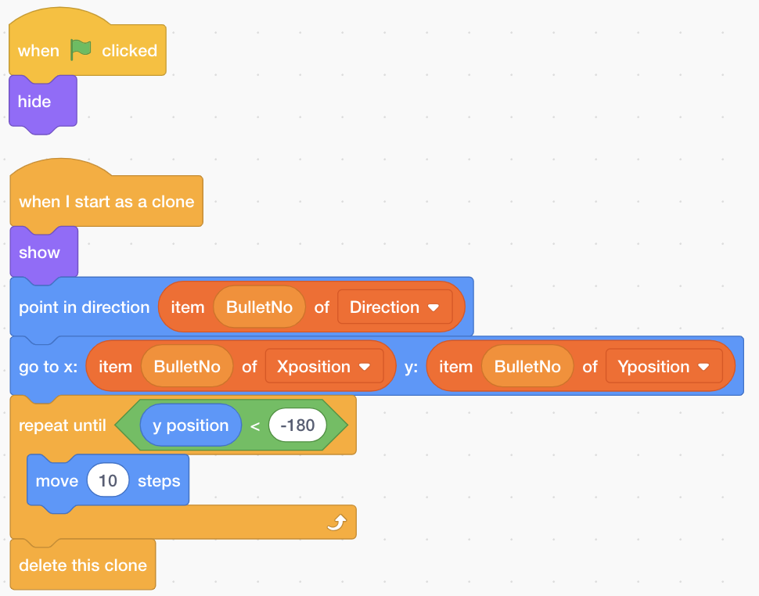

**Moving plane**

**BulletNo is Variable for all sprites.**

**Direction is List for all sprite.**

**Xposition is List for all sprites.**

**Yposition is List for all sprites.**

**laserRed16**

## **Space Fight**

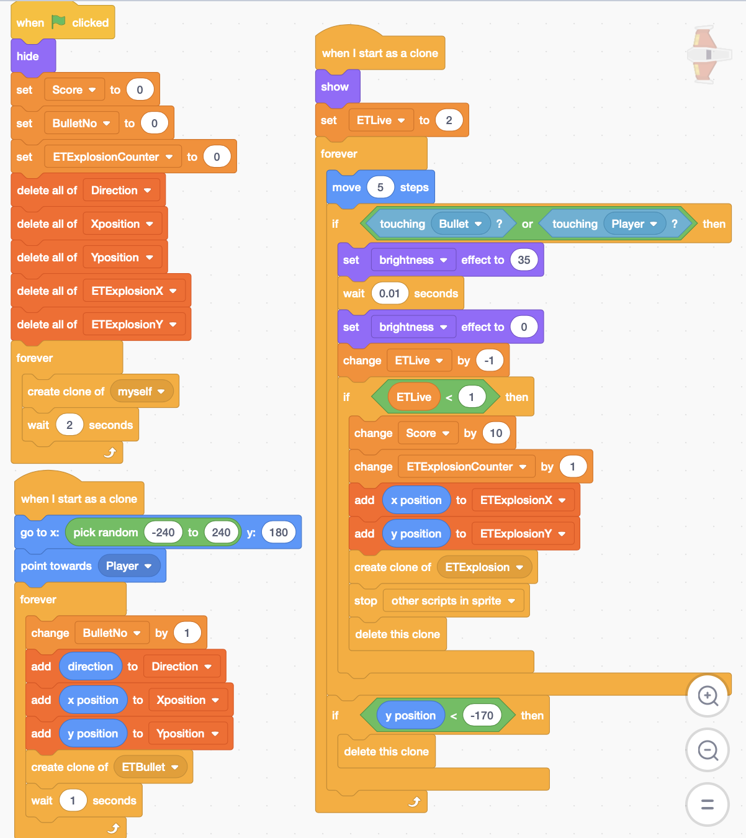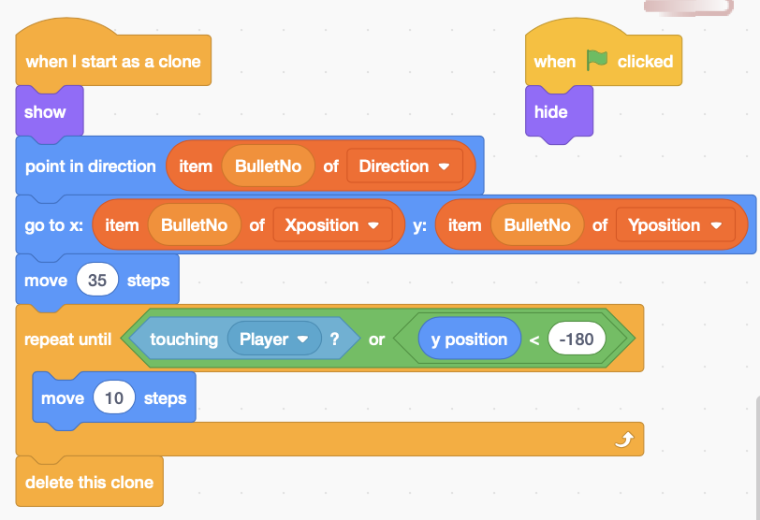

**ET Bullet**

**ET Plane**

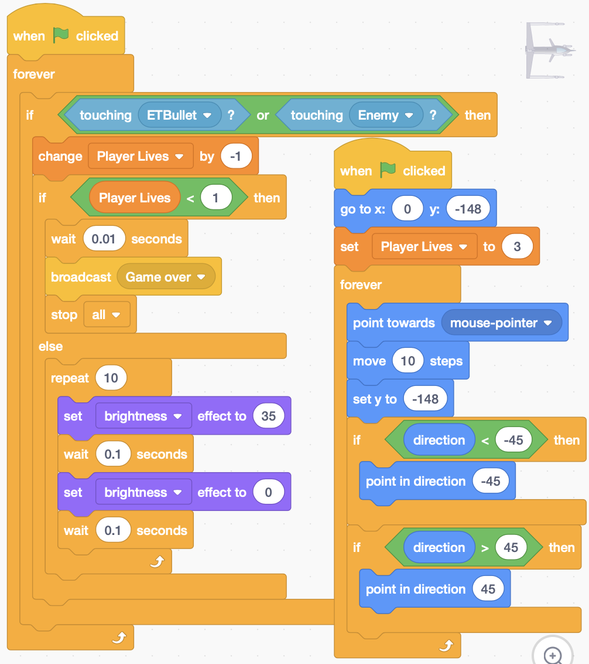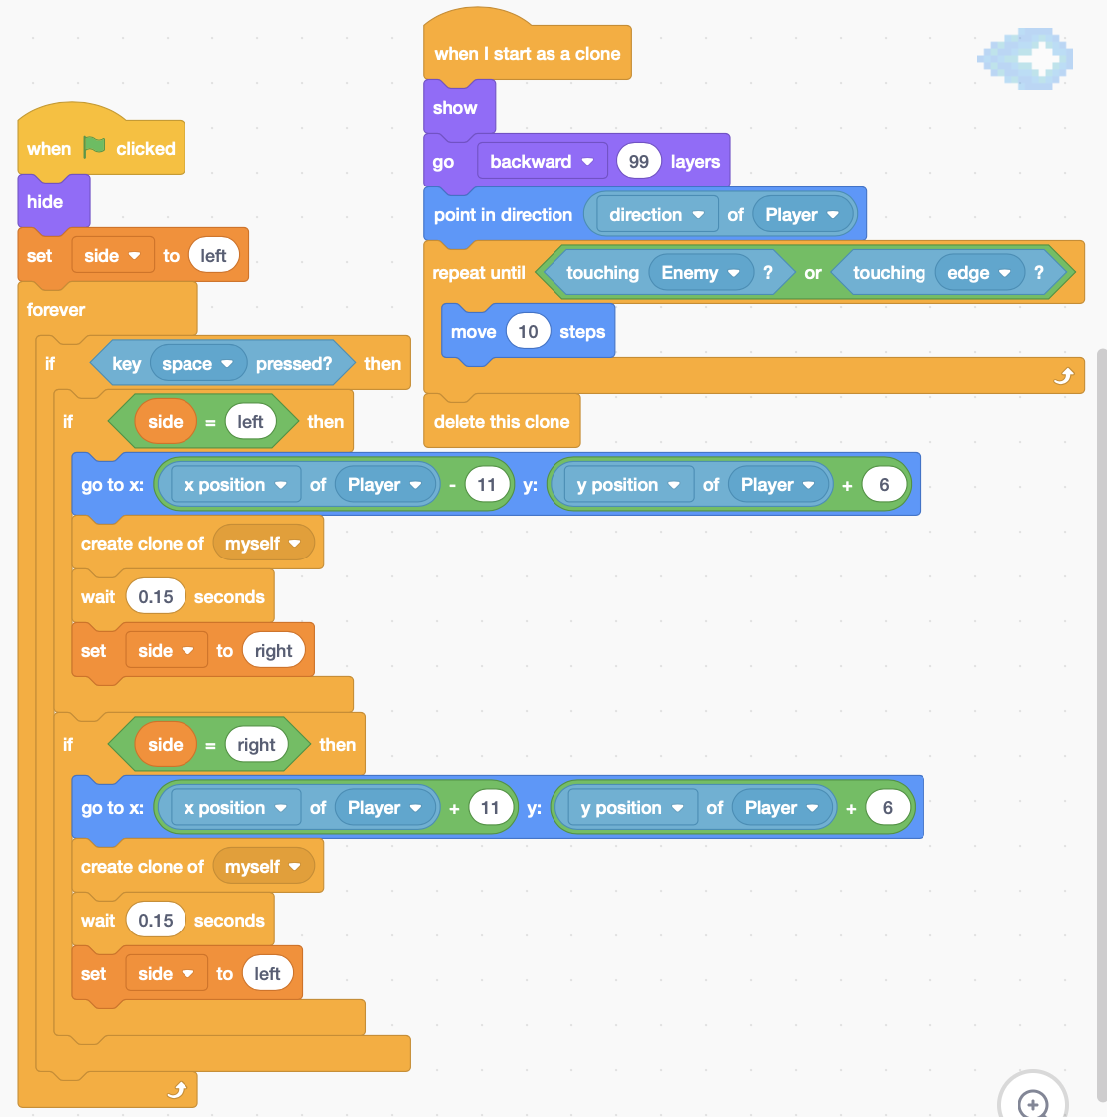

**Player Bullet**

**Player Plane**

# **String operate**

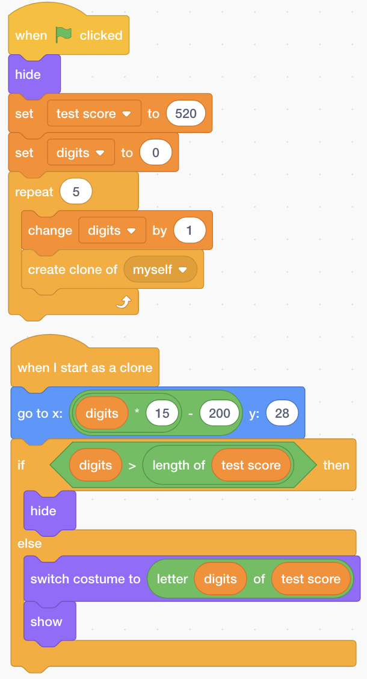 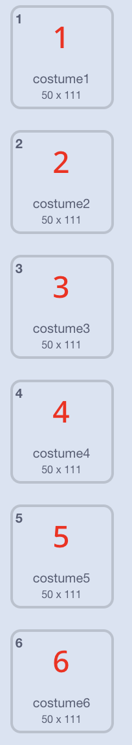

**克隆成5位字符串**

**大于字符串长度的数字都隐藏**

**每隔15显示一个数字**

## **Render Text with your own font**

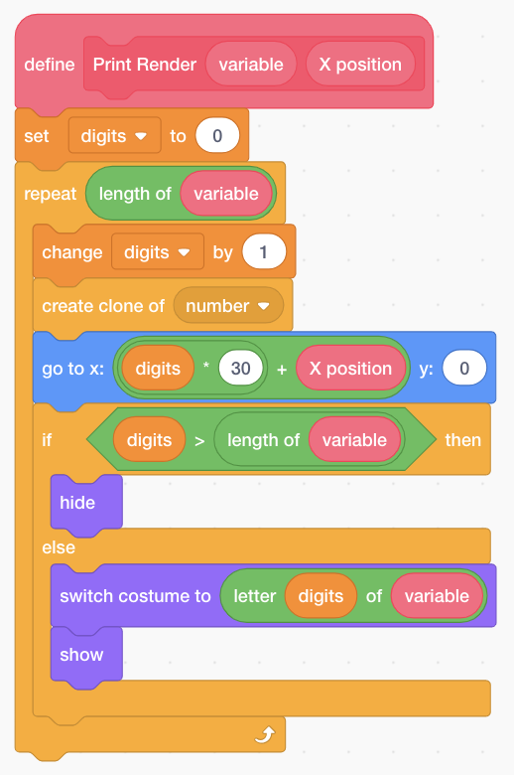

# **Pen tool**

## **Rainbow painting / Random Bubble / Mouse Tracing Bubble**

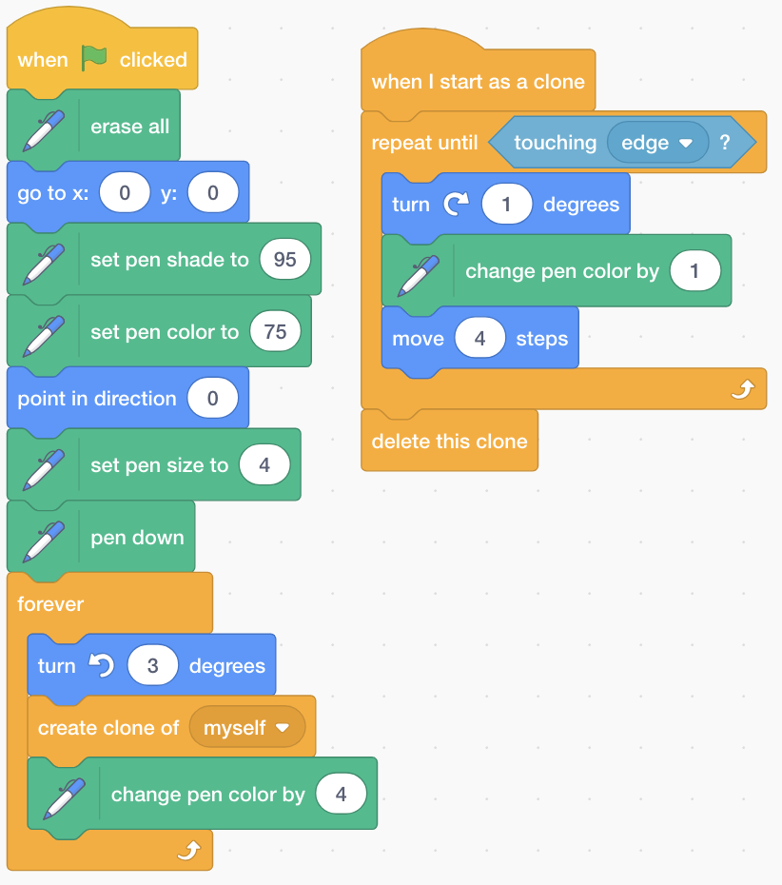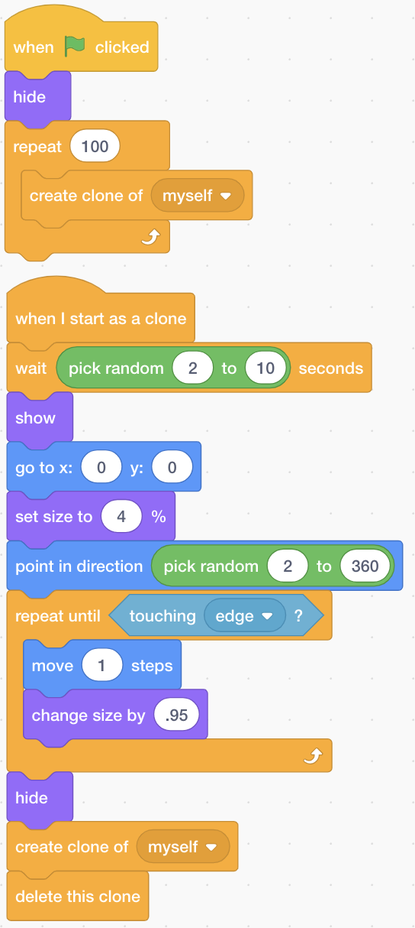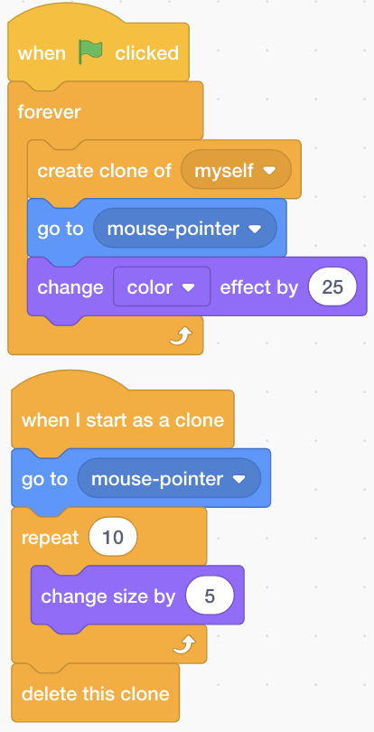



**Rotating rainbow pen**

**Mouse tracing bubble**

**Random Bubble**

# **Special Effect**

## **Shake screen**

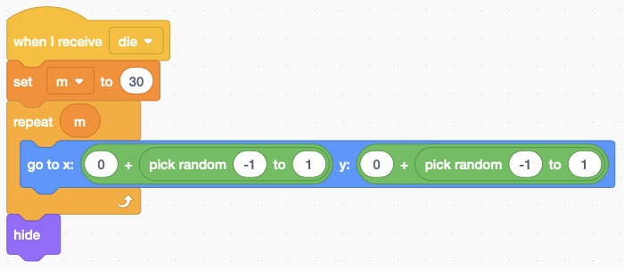

## **Shining and disappear**

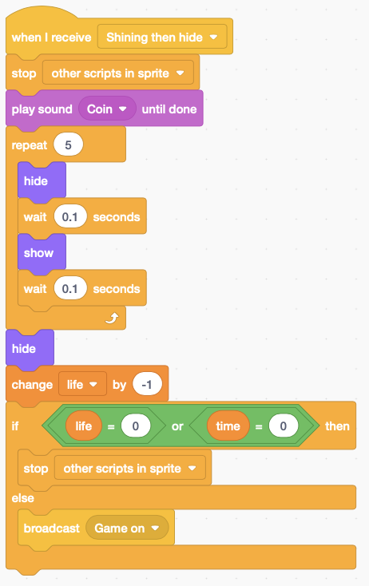

## **Rotating shrinking disappear**

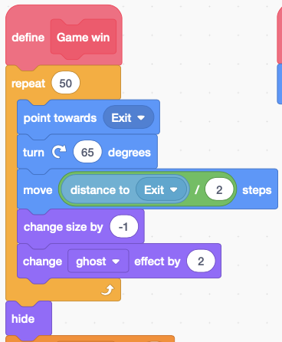

## **Rising platform**

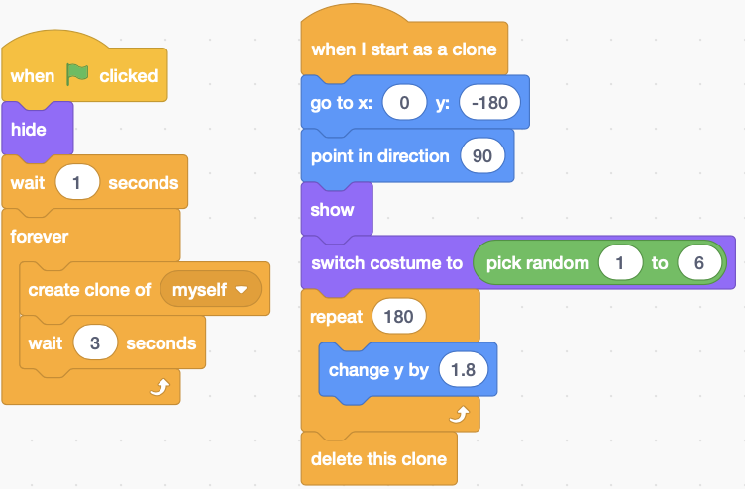

## **Rainbow drawing**

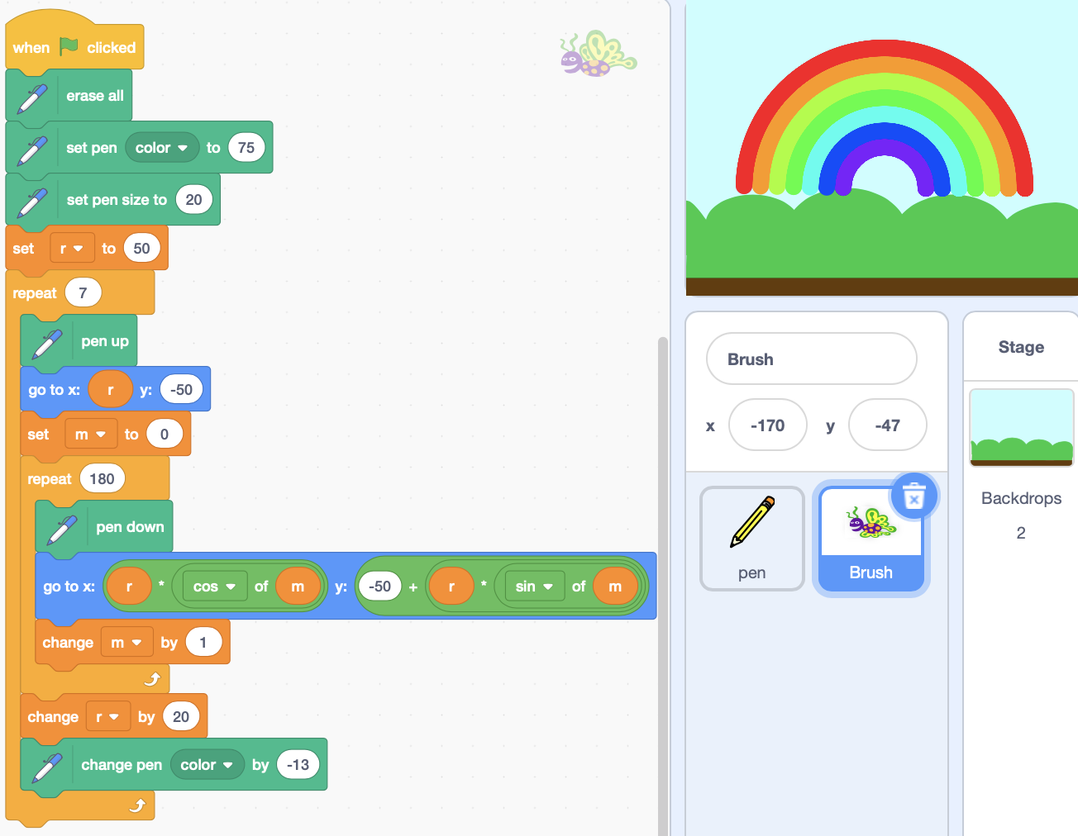

## **Move along the road**

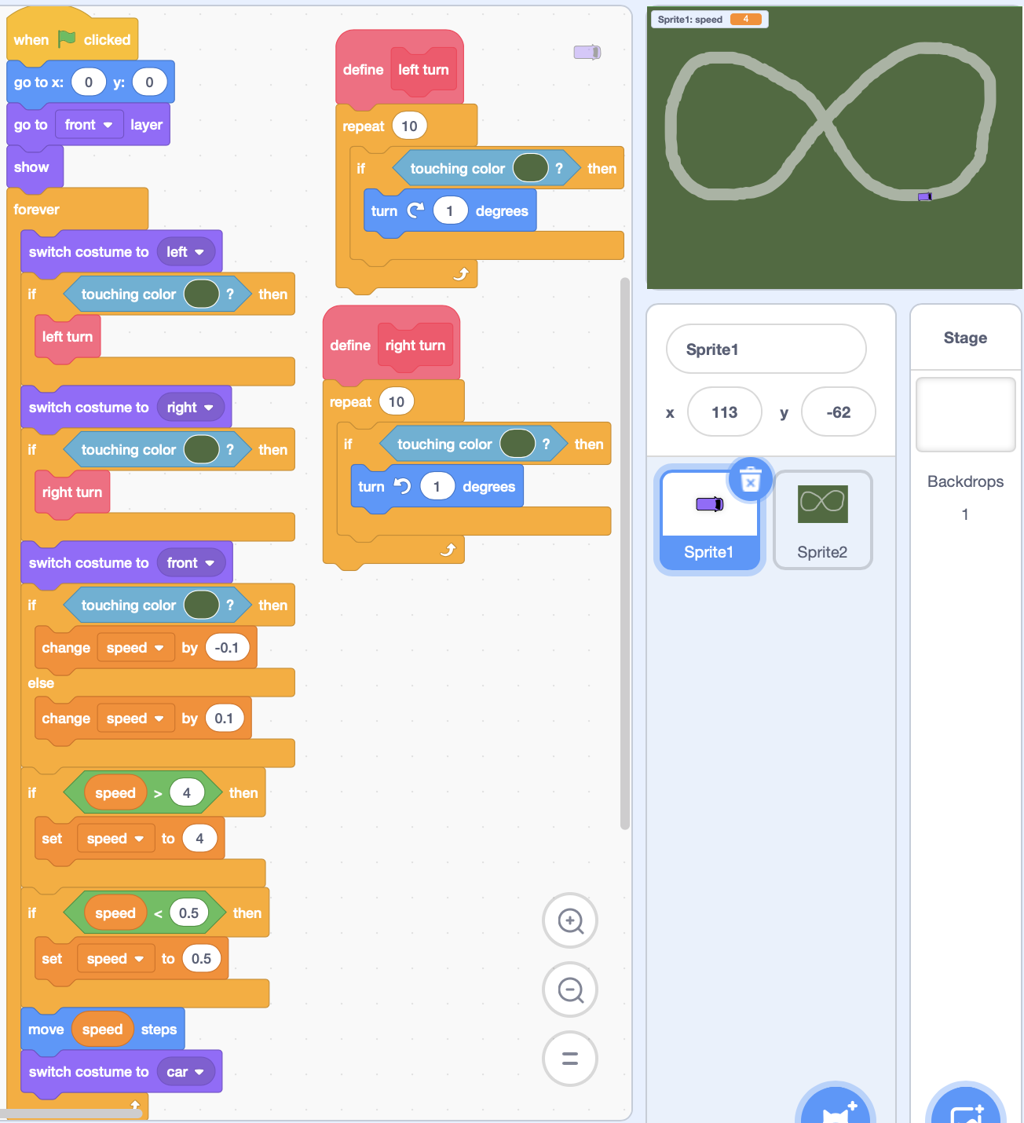

## **Snow effect**

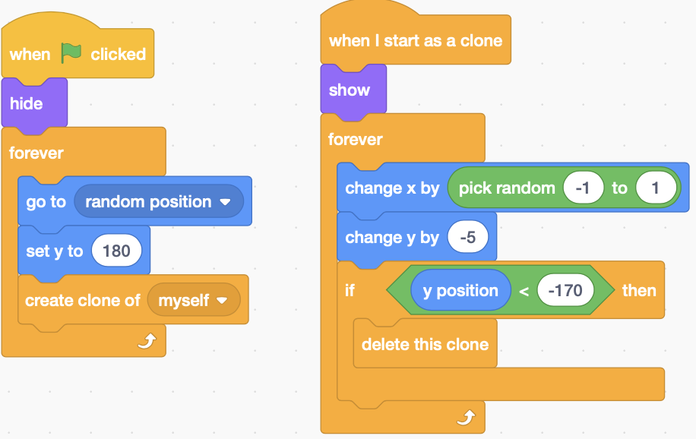

## **Falling leaves**

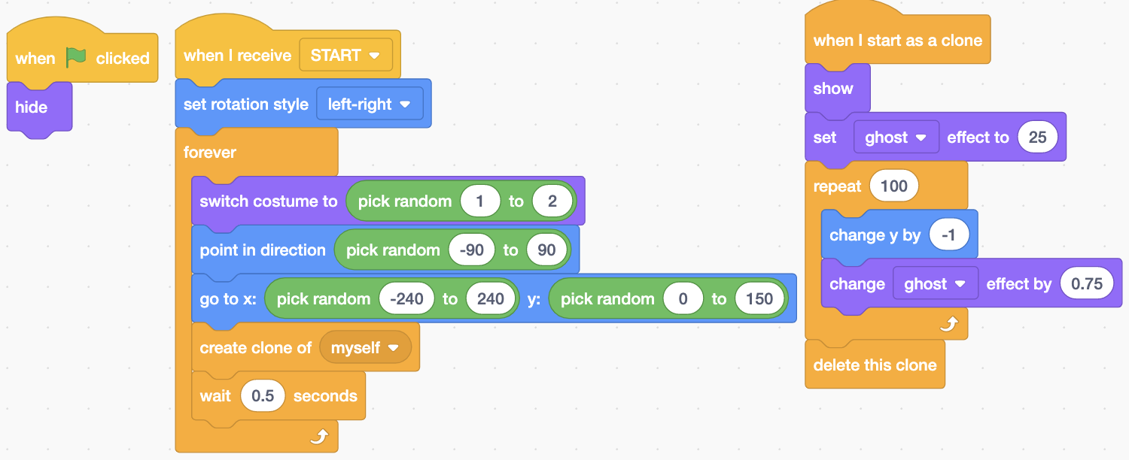

## **Spinning Wheel**

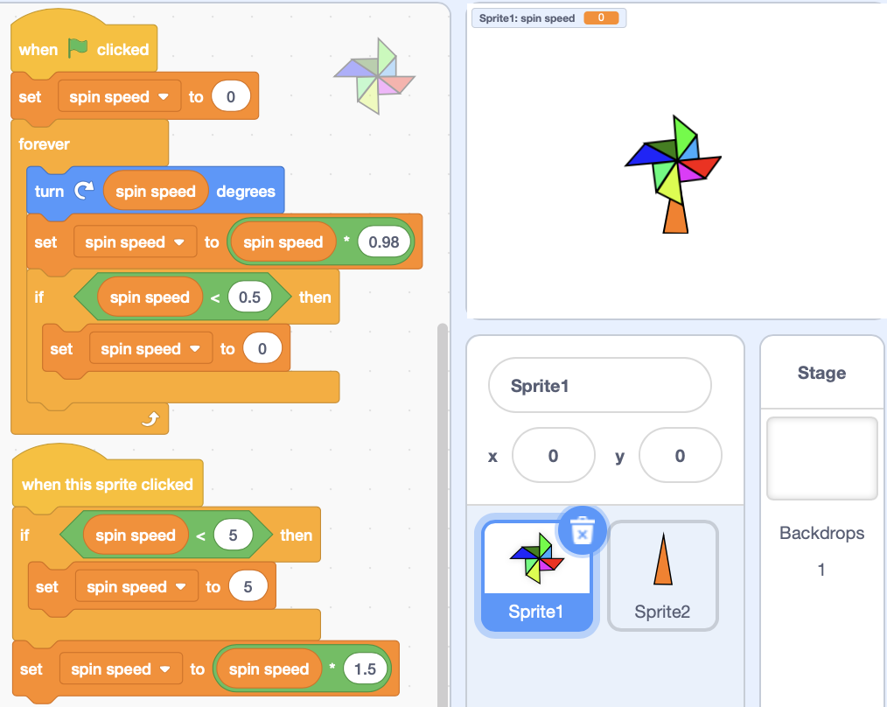

Moving Tail

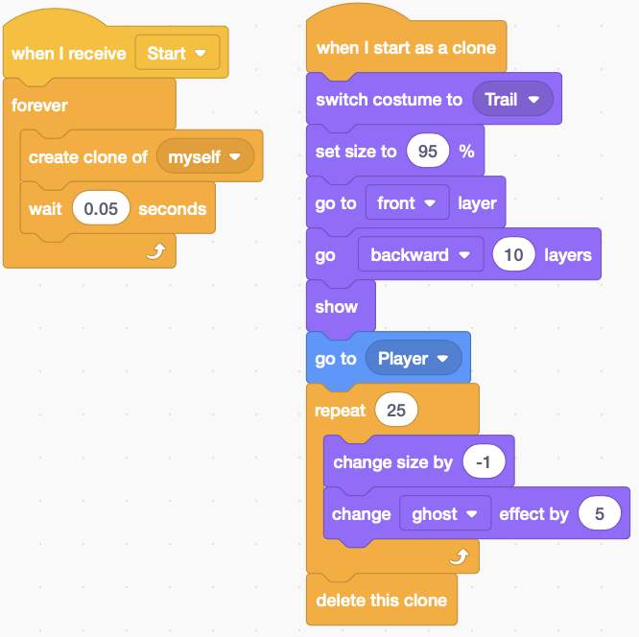

# **Tips**

X-axis is the 0 degree.

## **Draw a square**

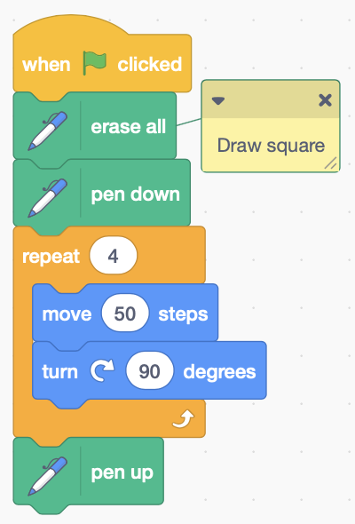

## **Bouncing**

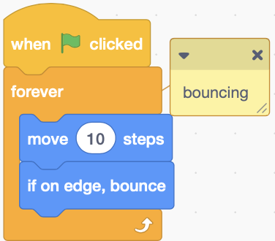

## **Forever -> If mouse down -> pen down Else -> pen up, Does not working**

The issue was that she was **clicking the paintbrush/blob,** **not the mouse,** an easy way to fix this is by **moving the dot to the right a bit more**.

## **Explosion effect**

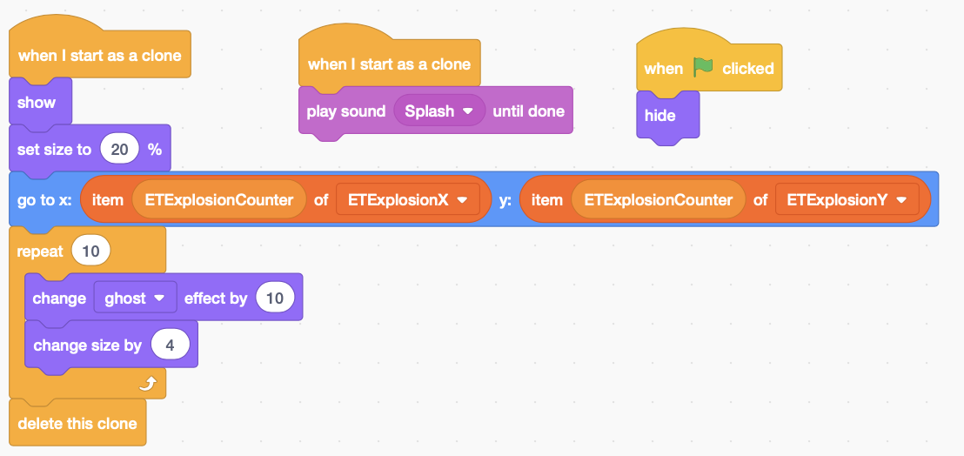

## **How to use backpack**

Backpack allow you to transfer costumes, sprites, sound and scripts from one project into another.

Drag what you want to transfer from screen to the backpack. Then drag it out to your desired project.

## **Round to two decimal**



## **Color trick game**

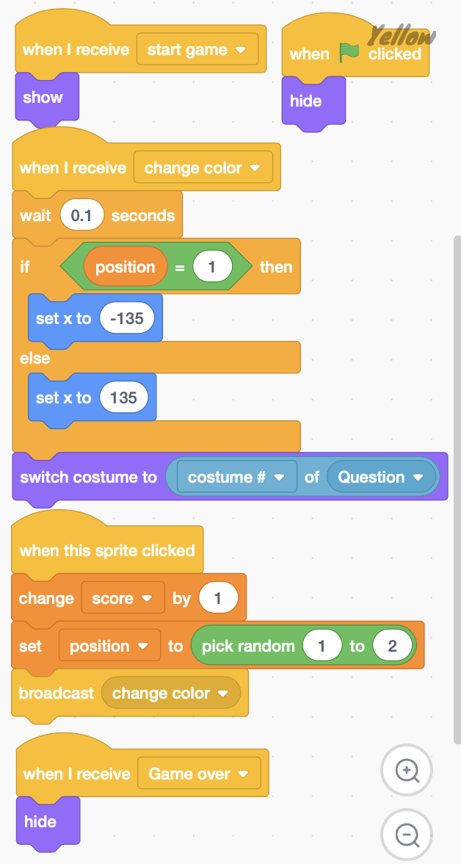 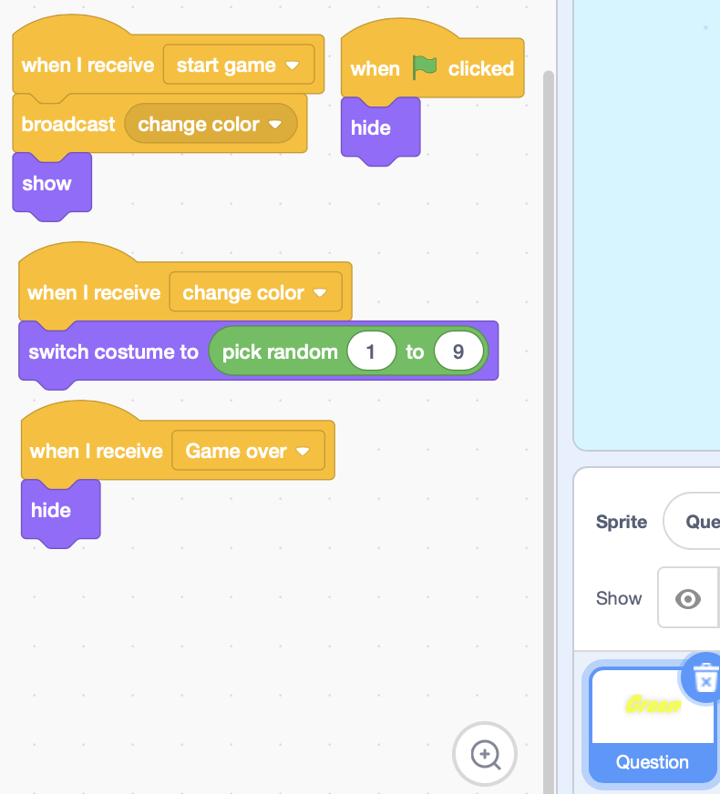



# **Basic concept**

## **Broadcast**

Broadcast message can cause other sprite to start doing things.